SoftSpace Flex
  - Affordable replacement pads for compatible headphones in India
Current update on 21 October 2026: V20 adds three reference pad bodies from published aftermarket dimensions. Exact Sony mounting fit and the proposed pressure, sealing and sound benefits remain unverified. See the final V20 chapter for results and first sample purchases.
We want a replacement cushion that presses less on glasses arms while keeping a good seal. The user keeps their headphone and replaces its removable pads. We are developing the contact idea together with our passive ear defender, but this is a separate product route.
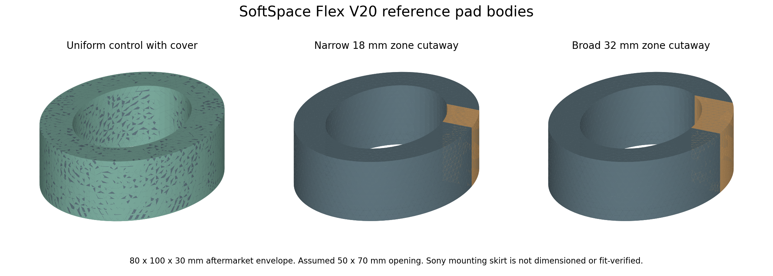
V20 uniform control and two soft-zone body candidates. Published aftermarket outside size; assumed opening and cover. The mounting skirt is not yet dimensioned or fit-verified.
Current conclusion: The idea is worth investigating. We have not proved less pain, unchanged music, no sound leakage or universal compatibility. The pad needs tests on each supported headphone model.
The shared standalone design is now V19. Its revised assembly and conditional joint calculations are recorded in the final chapters, including failed trials and refinement limits. The new V20 pad bodies use a published aftermarket envelope, but exact Sony mounting dimensions are still missing. No fit, comfort or sound benefit is proved.
The final standalone holding screen identifies a limited torque margin under assumed handling loads. This adds no measured Sony cushion benefit. The last chapters record the finding and the available data screening decision.
This document covers the market gap, the cushion design, the work completed and the tests still needed. Read SoftSpace Project for the full standalone-headband history.

The glasses problem and our proposed fix
A glasses arm sits between the cushion and the side of the head. It can concentrate pressure and lift the pad. The amount depends on the frame, the headphone force and the pad. A softer area may help the pad conform, but it can also create a weak seal if it is too soft.
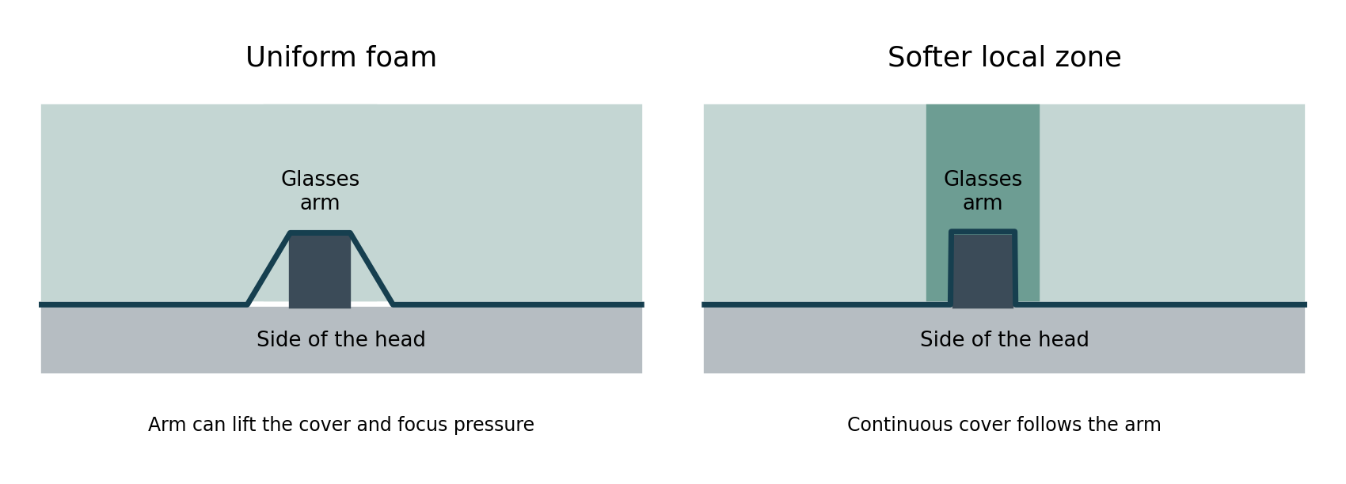
Concept drawing only. A softer area should compress around the arm while the cover remains continuous. It is not a measured seal.
Our pad has main foam, a local softer zone, a continuous cover and a carrier behind it. The numerical softer-zone ratio is 0.5, meaning half the main foam stress for the chosen compression curve. It is an assumption, not a selected material specification.
We are trying to avoid an open channel through the seal. However, a continuous cover alone does not prove an airtight seal: folds, seams, arm shape, mounting leaks and uneven force can still cause gaps.
For replacement pads we do not design the host headband. We still need to measure its force and cup shape because those affect the new cushion. A design that works on one headphone can fail on another.

First target Sony WH CH720N
We selected Sony WH-CH720N. Sony explains that its pad edge fits into a housing groove, with top and bottom slots and arrows aligned. This confirms replaceable pads; the instructions give no manufacturing dimensions for our replacement. [17]
Sony specifies an over-ear closed headphone, approximately 192 g, with 30 mm drivers and noise cancellation. [9] Our pad must preserve the mounting edge and avoid vents, microphones and driver clearance. The generic pad CAD is not yet compatible with this model. The user owns the headphone and plans to measure it later.
What to measure | Why it matters | Current value
Outer pad size, ear opening and depth | Ear space, contact area and cup distance | Not measured
Housing groove and pad skirt contour, depth and thickness | Fit and retention without an open leak path | Not measured
Top and bottom alignment slots | Correct seating and orientation | Not measured
Driver, vent and microphone clearance | Sound response and ANC behaviour | Not measured
Host force at worn widths and cup angle | Compression and pressure on glasses | Not measured
Glasses arm shape and worn contact path | Softer zone position and width | Not measured

Keep a continuous cover over the softer foam zone. This is a design hypothesis, not proof of zero leakage. Compare the original pad, new uniform pad and new soft-zone pad on this same headphone. Check seating, pressure, incoming noise with ANC off and on, outgoing music and frequency response. All host-specific results are still untested.

WH CH720N replacement pad comparison
Option | What is advertised or planned | Price evidence | What remains unknown
Crysendo [18] | Indexed seller listing claims protein leather, memory foam and WH-CH720N compatibility | Indexed INR 719 to 756; live price not verified | Glasses pressure, seal, delivery and stock
Geekria PRO [19] | Manufacturer claims memory foam, cooling gel, extra thickness and WH-CH720N compatibility | USD 23.99 for two pads; shipping extra | Delivered Indian price, glasses pressure and sound changes
Our candidate | Softer glasses zone under a continuous cover; model-specific skirt planned | No supplier or selling price yet | Sony mount fit, pressure, sound, ANC, durability and comfort

The Crysendo search result comes from an older indexed seller page. Its direct page could not be checked, so this is not a current purchase quote. Geekria’s product page was checked on 13 October 2026; Indian delivery and local stock were not checked. Manufacturer comfort claims are not matched test results. [18, 19]
Replacement pads already have competing listings. Our proposed advantage must be lower pressure around real glasses while keeping fit and sound acceptable at a useful cost. A memory-foam label or replacement-pad label alone does not establish that advantage. We have not proved our cushion is better.

What already exists and the Indian gap
Option | What already exists | Price or access | Our possible contribution
Turtle Beach ProSpecs [10] | Adjustable glasses relief with a tab that changes cushion depth; more than ordinary memory foam | Exact Indian model and delivered price not verified | Investigate pads for other removable-pad models
Noisefighters Sightlines [11] | Gel and acoustic foam pads with glasses relief cuts and adapters | USD 60 before shipping and imports; no confirmed Indian stock found in our search | Explore cheaper locally supplied compatible pads
Brainwavz oval pads [12] | Several pad materials and a fit guide | Indian delivered price and model fit need checking | Add a deliberate glasses contact region and test it
Wicked Cushions [13] | Model-specific replacement pads including cooling gel options | Indian delivered price not verified | Explore budget mounts and measured pressure/seal performance
Our concept | Softer local zone under a continuous cover | No supplier quote or sale price yet | Test affordable model-specific versions

We cannot honestly say this feature is absent everywhere in India. Our review did not confirm easy, inexpensive local access to specialist glasses-relief replacement pads for the budget models we want to serve. That is a market hypothesis to check, not proof that no seller exists.
We should choose a small set of popular removable-pad models, measure their mounts and ask users what they would pay. We should not promise one cushion for every brand or call our pad the cheapest before getting production quotes.

Budget ranges and compatibility
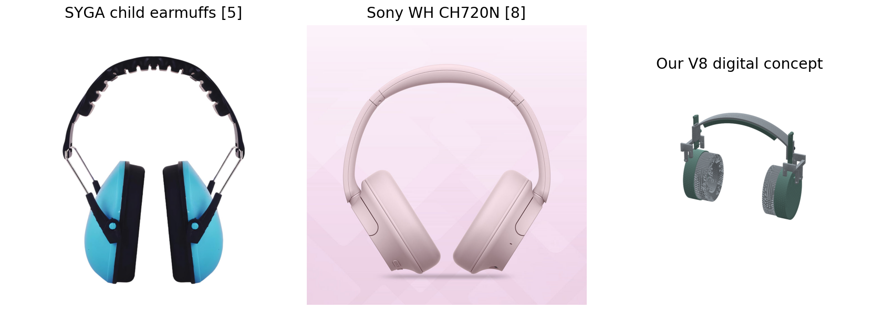
Examples of a child earmuff, an ordinary ANC headphone and our CAD. Replacement-pad fit for these market models has not been tested.
Headphone price band | What we should check before making a pad
INR 1,000 to 3,000 | Is the pad removable without damage? Can an affordable replacement still leave a useful price difference?
INR 3,000 to 5,000 | Measure mounting lip or clips, cup opening, pad depth and headband force.
INR 5,000 to 10,000 | Check isolation and bass as well as glasses pressure; choose exact models.
INR 10,000 to 20,000 | Test ANC behaviour and original-pad comparison on each model.
INR 20,000 to 40,000 | Compatibility and sound changes still matter; a higher headphone price does not guarantee a better glasses seal.

These are target price bands, not confirmed gaps in every band. They describe headphone purchase price, not a planned cushion price. No verified manufacturing or selling price has been calculated.
Original ordinary cushion | Existing specialist cushion | Our proposed cushion
Fits the model it was designed for | Needs its own supported mount or adapter | Current carrier is only a blank
Glasses feel varies with frame and force | Some products already use relief cuts or channels | Local softer region under a continuous cover
Known original sound for that headphone | Can still change sound when replacing the original | Must measure bass, response, isolation and leakage
Benchmark for our comparison | Benchmark for specialist benefits | Benefits remain unproven

Our development so far
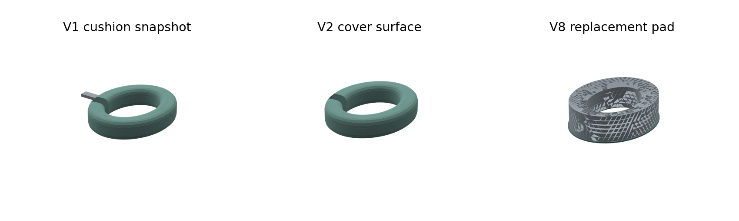
Saved cushion and cover geometry from early stages and V8. Colours are illustrative.
Stage | Pad work and evidence | Main limitation
V1 | Split a glasses contact region and added simplified frame references; 3,240 spring-contact cases | Independent foam cells; gaps remained; no real sound test
V2 | Compared 9,216 shapes and made a connected cover surface | Ideal contact was not proof of sealing; cover was not a solid wrap
V3 | Curved pads, solid cover envelope and scalar cover/foam calculations | No actual fabric, skin, friction, seams or measured materials
V4 | Cup alignment and coupled force study | Pressure peaks failed refinement; humid cases saturated
V5 | 72 pad comparisons and 6 mm virtual sensor checks | Stable averages, unstable point peaks; physical seal unknown
V6 | Corrected carrier/cover overlap and verified replacement STEP exports | Still no real headphone mount or acoustic-pad comparison
V7 to V8 | Pad concept retained while the own-defender band changed; V8 replacement exports checked | V8 acoustic cavity model does not calculate a real glasses leak
V9 | Standalone-band corner experiment with native candidates now exported | No new replacement-pad or measured leakage evidence
V10 | Standalone guide clearances corrected; Sony WH-CH720N selected for pad route | Generic pad unchanged; host measurements and leakage results missing

Which cushion checks passed and failed
Check | Recorded outcome | What it tells us
Simple compression and force balance | Passed under assumed inputs | The numerical equations are behaving as expected
Continuous V2 cover surface | Connected surface passed | Not a full volumetric cover or tested seam
V8 replacement exports | Six STEP files contain four solids each | The saved pad components can be imported
V6 and V8 nominal overlap audits | Passed for own-defender assemblies | Not proof of fitting another headphone
Average pressure refinement in V5 | Under 5% change for two nominal cases | Averaged model pressures are more stable
Point pressure refinement | Failed | Do not claim an exact peak pressure or pain reduction
Hot and humid moisture cases | Some reached saturation | Heat and sweat are not solved
Sound leaking in around glasses | No measured pass | Current contact gap values are not a leakage measurement
Music leaking out | Not tested | No zero-leakage claim is justified
Bass and sound quality | Not tested | Pad changes need headphone-specific response tests

Early V1 outputs showed lower frame pressure after reducing local stiffness. That reduction was partly built into the assumed model and is not evidence that our actual pad prevents headaches. Later cover models added coupling and revealed unstable point pressures. We should use the latest evidence rather than advertise the early percentage.

Noise getting in and music getting out
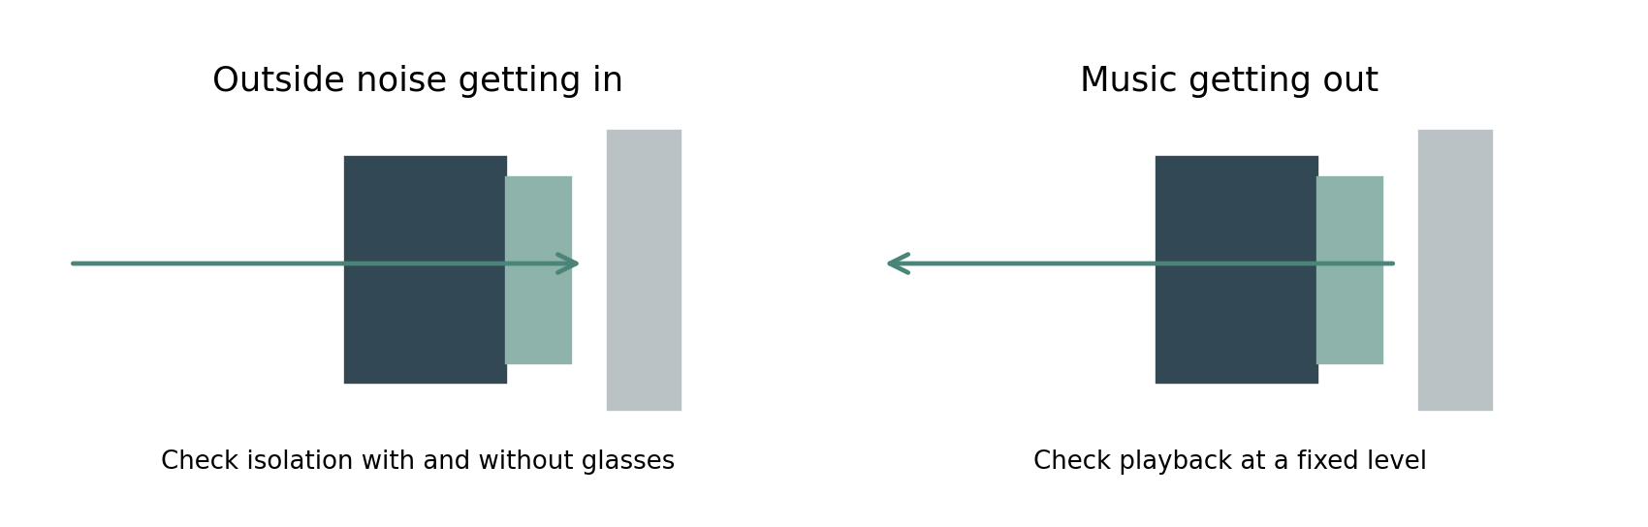
Two separate questions. Incoming noise and outgoing playback must each be measured. Diagram is conceptual.
For our passive defender there is no music driver, so outgoing music leakage is not a current product function. For a replacement pad on music headphones, we must test both directions and also check whether the pad changes bass or ANC performance.
The current acoustic work solves a hypothetical cup cavity. The improved model checks numerical stability across 48 sampled frequencies from 31.5 Hz to 8 kHz. It does not include a measured three-dimensional slit around a real glasses arm, real cover seams or a real headphone driver. It cannot answer how much music a nearby person will hear.
Zero leakage is not a result we can promise. Our working goal is to avoid a meaningful loss of isolation or increase in playback leakage compared with the original pad, while improving comfort. We will choose a numerical acceptance limit only after measuring the original pad and agreeing on the use case.

The tests needed on each supported model
Test | Comparison and method | Status
Mount fit | Original and new pads on the exact headphone; clips, lip, pull-off, cup clearance | Not done
Incoming noise | Repeatable external sound field; levels near the ear with no, thin, thick and curved glasses arms | Not done
Outgoing playback | Same measured level inside the cup; microphones outside at fixed distances and positions | Not done
Music response | Original and new pads on the same fixture; frequency response, especially bass; ANC on and off where available | Not done
Pressure and comfort | Pressure mapping plus voluntary feedback at measured clamp forces | Models only
Heat and moisture | Same ambient conditions and duration; temperature and humidity measurements | Models only
Movement and repeatability | Re-seat pads and glasses repeatedly; turn head and check several users or fixtures | Not done
Durability | Cleaning, compression recovery, foam ageing, cover wear, bond and mount retention | Not done

Test an original pad, a uniform new pad without the soft zone, and our soft-zone pad. Where possible, add an existing specialist pad. That separates the effect of changing the whole cushion from the effect of our glasses zone.
Use the same headphone, frame position, test signal, fixture and inside-cup playback level. Matching only the volume-slider setting may be misleading because pad changes can alter the sound level at the ear. Repeat the fit several times and show the range of results.

What is still missing and what comes next
We need real foam compression and recovery curves, cover stretch and friction, frame shapes, head geometry and measured forces from the host headphones. We also need a finished seam, bond and mounting design. The continuous cover and softer zone should be checked together, not treated as separate guaranteed fixes.
Start with the selected Sony WH-CH720N, whose pads can be replaced. Measure its original mount before changing the carrier or skirt. Make original, uniform and softer-zone samples. Check fit and retention first, then measure incoming noise, outgoing playback and frequency response. Improve the geometry using those results before expanding to more models.
Affordable Indian supply is our intended direction. It becomes a supported business claim only after we confirm a real demand gap, supplier costs, model compatibility and measurable improvement. The standalone autistic-user defender remains the first-priority project; this pad route can share learning and materials.
Update date | Shared evidence status | Change to this document
13 October 2026 | Initial living reports | First living Word edition. Added CAD pictures, existing competitors, honest Indian availability wording, version history, leakage limits and a model-specific test plan.
13 October 2026 | V9 native candidates | Updated native V9 export and structural evidence for 6 sizes. The replacement pad has no new physical leakage or comfort evidence.
13 October 2026 | V10 clearance candidates | Wider audit found missed V9 shortest-setting clashes. Added V10 guide and knob candidates. Replacement cushion unchanged.
15 October 2026 | V10 actual width fixture study | Actual-width fixture checks completed for 6 of six sizes. Updated refinement and conditional strength evidence, solver failure history and Sony pad competitors. No measured cushion benefit.
15 October 2026 | V12 local folding candidate | Added wider guide channels, a folding lock candidate, component calculations, revised motion checks and unresolved assembly and product-validation requirements. Replacement Sony cushion compatibility is still untested.
15 October 2026 | V14 rear cap candidates | Retained the failed V13 assembly path and added the rear cap candidate with explicit test status. Sony mount and physical benefits remain untested.
15 October 2026 | V15 retention and packing experiments | Added one adult small threaded knob and jam nut experiment, a child packing search on unchanged V14 parts and conditional retention load calculations. No physical or Sony pad pass is added.
15 October 2026 | V16 indexed folding candidates | Added folded-position index holes, recessed rivet retention, different child and adult layouts, retained failures, material-reference calculations and blank physical-test records. Sony fit and physical benefit remain untested.
15 October 2026 | V17 two size entry pilots | Larger index holes and entry cones tested on child large and adult small. V16 remains the six size candidate.
16 October 2026 | V18 passive hinge and wearing stop | Six sizes and component checks retained. Added final material, pivot clearance, CAD stack and handling load screens. Retention risk and missing physical inputs are recorded.
16 October 2026 | V19 prototype handoff | Six sizes revised. Added two disc springs, longer pin envelopes, second nuts, coupled joint development, retained failures and measurement forms. No physical validation or manufacturing release.

Update this document whenever pad geometry, materials, host-model fit or sound results change. Also update SoftSpace Project so both reports stay consistent. Record failures and replace obsolete claims; do not only append good results.

Latest shared CAD and simulation results
V10 corrects the guide and knob clashes found in the standalone V9 shortest setting. All 18 native V10 STEP poses passed the all-body overlap audit. Six saved Fusion archives reopened with 28 solids in each V10 component. This is geometry evidence; it does not test glasses comfort or sealing.
The 42 current native and local standalone CAD files also match the hashes recorded in their checks. This ties those results to the saved files.
The quarter-band displacement comparisons pass in all six sizes. 6 of 6 recorded stress comparisons pass 5%. That ideal model mirrors a front clamp bore onto the rear wall. It is not the complete worn assembly.
The separate actual-width fixture study covers 6 of six sizes. Its recorded guide-compliance comparisons all pass our chosen 5% limit. Sampled peak-stress comparisons pass in 6 of those sizes. Earlier coarse-to-fine peak changes above 5% and memory failures remain in the history. Read the main report for the current refinements. These ideal fixtures still omit real scalp, joint and clamp contact.
The standalone quarter-fixture force screen has 54 cases. An additional 54-case screen uses the actual-width fixture. The force screens use assumed materials and synthetic heads. A conditional material-strength screen uses predicted forces and illustrative margins; it has no measured strength or durability pass. These calculations do not measure the Sony headband force or prove a replacement pad reduces pressure, incoming noise or outgoing music.
The generic V8 replacement pad is unchanged and is not claimed to fit Sony WH-CH720N. At the V19 stage its mount had not been measured. The V20 chapter now uses a published aftermarket envelope and keeps the exact skirt and groove dimensions open. Host fit, retention, incoming noise, outgoing playback, frequency response, ANC behaviour and wearer comfort remain untested. Both reports will be updated when those dimensions or results arrive.

Sources and project records
[5] SYGA Indian child earmuff listing
[8] Sony WH CH720N Indian store price
[9] Sony WH CH720N specifications
[10] Turtle Beach adjustable ProSpecs glasses relief
[11] Noisefighters Sightlines gel relief pads
[12] Brainwavz replacement pad fit guide
[13] Wicked Cushions cooling replacement pads
[17] Sony WH CH720N pad replacement instructions
[18] Crysendo indexed Sony replacement pad listing
[19] Geekria Sony cooling gel replacement pads
Web information was checked on 13 October 2026. Prices, coupons and stock can change. Links are evidence sources, not buying recommendations. CAD images were rendered from our saved STEP files; they are not manufactured product photos. SYGA and Sony photographs came from the linked seller pages and are used only to identify the compared products.
Primary local evidence: cad_build_report.json; cover_prototype_report.json; shape-study-results/report.md; engineering-v3-results/contact_summary.json; engineering-final-results/REVIEW.md; engineering-v5-results/REVIEW.md; cad_v8_report.json; cad_v8_audit.json; engineering-v8-results/STEP_verification.json; engineering-v7-results/acoustic_p2_summary.json. The named files are saved in EarDefenderProject.

Additional travel and tolerance checks
We checked 42 standalone V10 poses: all six sizes at 0, 5, 10, 15, 20, 25 and 30 mm extension. All sampled poses passed the nominal rigid-body overlap check at a 0.01 cubic mm threshold. This covers more positions than the earlier endpoint audit. It does not prove continuous clearance between samples or clearance when the band bends.
The band, crown pad and two clamp knobs moved as one group. All 28 solids were covered. Pairs within the same rigid group were checked once per size and reused because their relative positions do not change. The CAD source hashes are recorded. The results use local geometry calculations on the native STEP exports; no new Fusion simulation or physical test was run.
Pair | Smallest gap | Remaining gap with 0.2 mm error per part
guide to pivot pin | 1.000 mm | 0.600 mm
guide to tongue | 0.217 mm | -0.183 mm
knob to fork | 0.500 mm | 0.100 mm

The expanded tolerance budget has 1296 calculations over 12 assumed error levels. It reuses the recorded minimum distances. For the guide and slider tongue, equal errors must each stay below 0.109 mm to guarantee any positive gap under this simplified rule. At 0.2 mm per part the gap budget is negative. This means manufacturing clearance is not established; it does not prove that every real slider will jam.
An illustrative 0.2 mm error per part plus a 0.1 mm remaining gap would need at least 0.500 mm nominal clearance. The current minimum would need about 0.283 mm more. This is a design input to investigate, not an approved production tolerance. Increasing the gap also needs checks for play, alignment, strength and locking. The CAD has not been changed by this test.
For the Sony replacement cushion, the pad geometry and host fit remain unchanged. These standalone headband checks do not measure the Sony clamp force or validate our pad. Native Word page layout remains unverified. These results are separate from real comfort, sensory acceptance, sound reduction and leakage tests.

Tests that still need inputs or physical samples
Test group | What is still needed | Current outcome
Foam and cover | Compression and recovery curves, cover stretch, friction and seam construction | Assumed models only
Worn contact and fit | Measured heads, glasses paths, joint behaviour and nonlinear contact | No validated worn assembly result
Band and locks | Material strength, creep and fatigue; real clamp threads, friction and torque | Conditional strength screen only
Adjustment and retention | Clearance specification, stops, pull-out and repeated adjustment tests | Sampled rigid travel passes; retention open
Heat and moisture | Measured material data and timed warm humid wear trials | Earlier model cases saturated
Sound and leakage | Real cup, seal and material properties; acoustic fixture and repeated fitting | No measured attenuation or leakage pass
Sony WH CH720N | Original pad mount, cup, vent and frame measurements | User will measure later
Wearer feedback | Voluntary trials with autistic users and glasses wearers | Comfort and acceptance untested
Manufacturing and cost | Supplier samples, dimensional capability and quotes | Production readiness and price unproven

The saved test register separates finished calculations from tests needing inputs. We cannot complete the physical tests in CAD. We will use the measured inputs to replace assumptions and compare the original, uniform and softer-zone pads on the same headphone. Until then there is no claim that our product is better than a market product.
Shared update on 14 October 2026: added intermediate slider positions and the expanded tolerance budget to both reports. Earlier failures remain recorded. Source records: intermediate_travel_audit.json and tolerance_budget_expanded.json.

Slider stop contact and unfinished validation
The native V10 slider already has an outboard shoulder that obstructs the guide during overtravel. We removed the two clamp knobs in the numerical model to represent an unlocked assembly, then imposed six axial positions from 30 to 75 mm in each size. These are diagnostic poses outside the intended range, not positions we recommend using.
Check | Recorded finding | Meaning
36 overtravel poses | Guide and tongue overlap at imposed 40, 50 and 60 mm settings in all six sizes | The existing shoulder creates a rigid geometric obstruction
12 contact onset searches | Contact begins near 31.000 mm on both sides of every size | About 1 mm beyond the intended 30 mm range
Numerical bracket | Contact threshold located within 0.001 mm intervals | Numerical location only; not manufactured accuracy
Imposed 70 and 75 mm poses | Shapes are beyond the stop and separated axially | Not a reachable pull-out path: intervening positions clash
Stop strength and retention | Not tested under load | No pull-out force or durability rating

The contact search used exact CAD minimum distances. It did not solve the stress or deformation when the shoulder is pulled against the guide. The stop can exist geometrically and still need strengthening. We need the chosen material, manufacturing method and proof-load requirement before validating this part.
Locking remains separate. The saved clamp knobs are shape placeholders. A loaded clamp test needs the final thread and insert geometry, tightening torque, contact friction and wear behaviour. Full worn-contact work also needs measured foam and cover properties, head shapes and the real glasses contact path. The earlier ideal headband-force studies do not replace those inputs.
For the replacement pad route, these are standalone defender results. Sony WH-CH720N mount fit, original clamp force, acoustic response and ANC behaviour remain untested. Its original pad and groove still need measurement. The current generic cushion has not been changed by these checks.
Physical validation remains unfinished: real compression and recovery, locking and pull-out, repeated adjustment, drops, cleaning and ageing, timed heat and moisture, incoming noise, outgoing playback and voluntary comfort trials. The test register identifies these as open. No software run can establish a real material curve or a wearer preference without measurements.
Shared update on 14 October 2026: added stop geometry and overtravel evidence to both reports. Sources: overtravel_audit.json and stop_onset_audit.json. The CAD revision remains V10; no geometry was edited in this batch.

V11 Material and folding study
We expanded the search after the request to consider ordinary and unusual materials, folding and resistance to breakage. The current native CAD is still V10. V11 records material calculations and folding poses made from those saved solids. It is not a new finished hinge assembly or a physical durability test.
The register contains 70 candidate families: 32 for the band and hardware, 20 for cushioning, and 18 for covers and liners. Ten specific material references have numerical band screens. The other families are ideas awaiting grade data, not tested winners. A material family can contain many formulations with very different behaviour.
Cushion and compliant zone: conventional flexible PU foam, high resilience PU foam, slow recovery memory PU foam, microcellular PU PORON, silicone foam, soft solid silicone gel, encapsulated gel insert, natural latex foam, synthetic latex foam, EVA foam, expanded PE foam, expanded PP foam, expanded TPU beads, printed TPU lattice, silicone lattice, 3D spacer textile, cork rubber composite, air bladder, water or hydrogel pouch, phase change insert.
Cover and liner: PU coated polyester, PVC synthetic leather, microfibre synthetic leather, woven polyester, polyester velour, cotton jersey, bamboo viscose knit, wool blend, nylon spandex knit, 3D spacer face fabric, silicone skin, breathable monolithic TPU film laminate, ePTFE laminate, thin natural leather, cork fabric, recycled PET knit, removable washable textile sleeve, melamine acoustic liner.
The aim is to identify useful combinations, not to find an unusual material at any cost. No Indian supplier prices, production yield or novelty search has been completed. Comfortable, cheap and hard to break remain design goals.

Cushion and cover material findings
Published foam reference | Reference point | Flat ring force N
PORON 4701 30 240 kg/m3 | 25 percent compression | 89.5
PORON 4701 30 320 kg/m3 | 25 percent compression | 149.1
PORON 4701 30 400 kg/m3 | 25 percent compression | 264.2
BISCO BF1000 | CFD test point | 70.3
BISCO BF2000 | CFD test point | 42.6
Infinergy 230 at 10 percent | 10 percent compression | 106.5
Infinergy 230 at 50 percent | 50 percent compression | 1065.2

These 14 calculations cover adult and scaled child projected rings at individual published stress points. They do not model our curved cushion, actual contact area, cover tension or a real glasses arm. The forces in the table are what uniform compression across the entire flat ring would require at that point. They are not measured headband forces or a comfort ranking.
The industrial foam examples need much more force at their reported points than our earlier few-newton band estimates. That is a warning against substituting a foam because it is called soft. The test conditions differ, and the low-load compression curves are still missing. The cited PORON sheets are also much thinner than our pad; a 20 mm layered pad is not validated by those data.
A continuous breathable TPU film under a soft textile face is a useful cover experiment. Covestro describes Platilon M as wind tight, water vapour transmitting and low noise. Baltex describes spacer fabrics for airflow and cushioning. We infer that a thin film plus textile may help us study moisture and surface feel while retaining a continuous layer. Neither source proves headphone isolation, lower ear temperature or autistic acceptance.
Keep flexible PU and memory foam as comparison samples. Investigate softer silicone or a TPU lattice for the local glasses region only after obtaining its compression curve. Lattice shape, rubbing noise, recovery, seam life and sealing need tests. No material is selected as a final winner yet.
Material data poron
Material data silicone
Material data silicone soft
Material data etpu
Material data film
Material data spacer

Folding results across six sizes
Size | Best sampled angles | Envelope change
adult large | 75 and 60 degrees | 23.5 percent smaller
adult medium | 75 and 60 degrees | 23.6 percent smaller
adult small | 75 and 45 degrees | 12.3 percent smaller
child large | 60 and 45 degrees | 3.5 percent smaller
child medium | 60 and 45 degrees | 3.5 percent smaller
child small | 75 and 45 degrees | 5.2 percent smaller

These poses use the existing fork pins as rotation axes. Before folding, the left side is set to 0 mm extension and the right to 30 mm. Both cups and their forks then rotate inward in sequence. The comparison is with each original nominal V10 bounding box, not with a market headset or a carrying case.
The first symmetric folds, direct cup-pivot folds and some 75 or 90 degree staggered attempts collided. Those failures are saved. Two child sizes needed a shallower first rotation. A final pose is counted only when its preceding sampled sequence is also clear. Packing volume alone does not establish ease of carrying or protection in a bag.
The finer check covers 150 poses at 5 degree intervals. All recorded samples passed the 0.01 cubic mm intersection threshold. 6 candidate STEP files were exported from passing size sequences. This remains sampled rigid motion; it does not prove continuous clearance or clearance under tolerances and loads.
Rigid when worn and foldable for carrying require a controlled joint. The saved model still lacks a validated angular latch, rotation stops, friction specification and protection against pinching. The earlier intact-band stress results do not certify these joints. No drop, repeated folding or bag compression pass is claimed.
This folding study belongs to our standalone defender. It does not make the Sony WH-CH720N foldable or change its original headband. Replacement pad compatibility and sound tests still need the Sony measurements and physical samples.

Folding CAD and the next durability checks
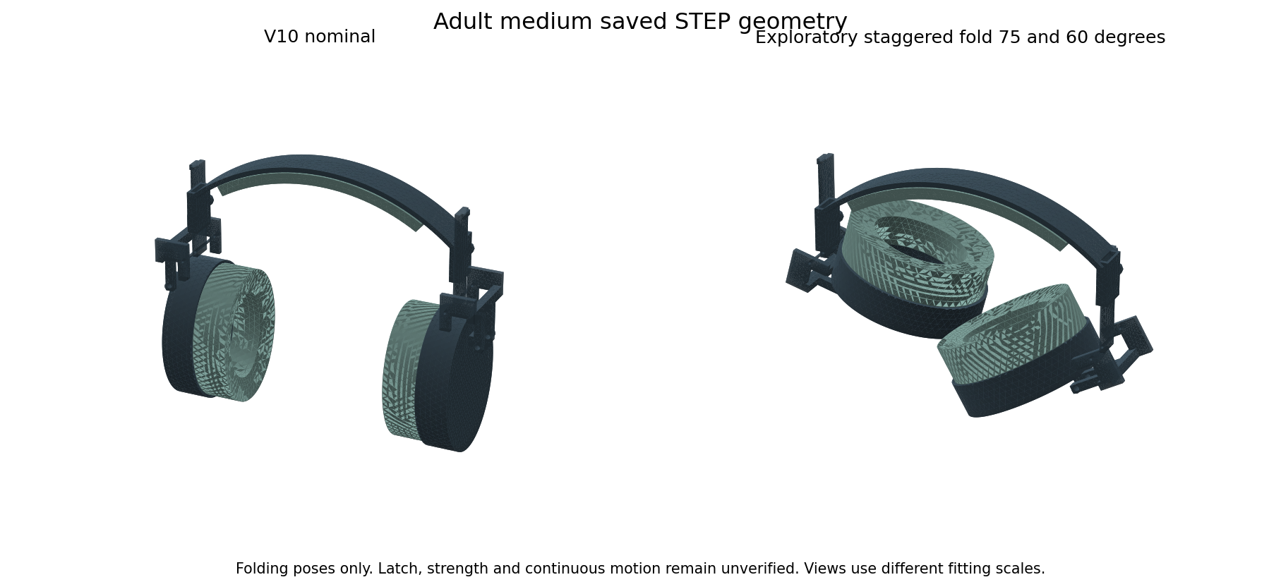
Actual adult medium STEP geometry before and after an exploratory fold. Views fit each shape independently. The triangles are display tessellation, not the cover texture. This is not a manufactured headset or a native Fusion hinge simulation.
Goal | Required validation
Rigid in use | Final latch geometry, bending and torsion stiffness, joint play and release force
Not easily broken | Material curves, stress at pins and stops, large deformation and physical overload tests
Repeated folding | Hinge cycles, fastener loosening, cracks, wear and force drift
Easy to carry | Continuous folding path, hand access, folded dimensions and real bag fit
Transport survival | Defined drop orientations, packed compression, crush recovery and repeat function
Comfort after ageing | Foam recovery, cover damage, sealing and voluntary wear feedback

All material data in this study were checked on 14 October 2026. They supplement the market review dated 13 October. The next engineering step is to specify and model the latch and final materials, then use samples to calibrate compression, friction, fatigue and acoustic inputs. These results do not establish an unbreakable product, zero leakage or a universal sensory preference.
Both living reports were updated together with the 70 family register, grade calculations, foam point screens and folding passes and failures. Primary local records are in engineering-v11-results. The Sony pad geometry and its untested compatibility status are unchanged.

V12 Shared progress and the Sony pad
The standalone defender now has six V12 STEP candidates with wider guide channels, an offset fork and a captive folding-lock pin. The independent audit records 216 passing rigid samples and all 18 STEP files pass solid-count and volume checks. V10 remains the latest native Fusion archive. This work does not change the Sony WH CH720N headband or validate a replacement pad.
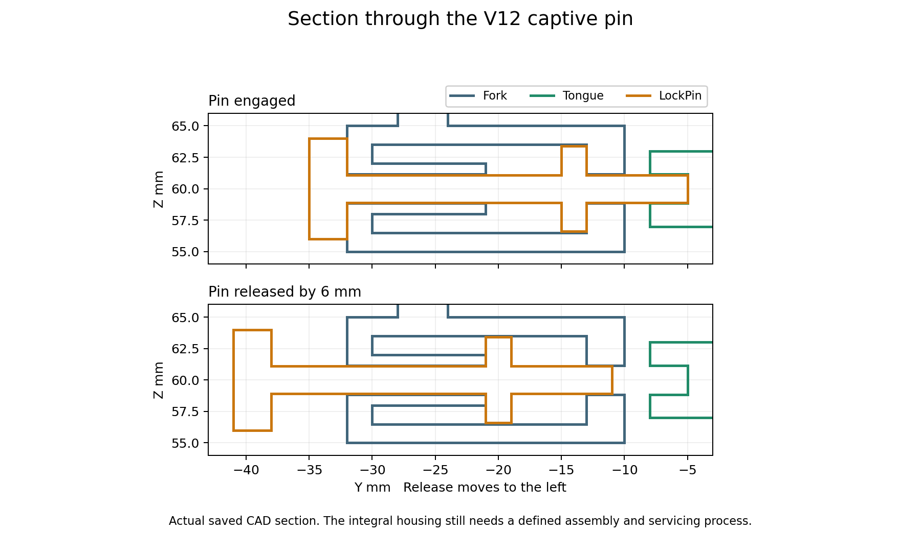
Section of the standalone V12 locking mechanism. This is shared project progress, not a proposed change to the Sony headphone. Its integral housing still needs an assembly and servicing design.
The standalone child folds give only about 1 to 3 percent reduction in the tight bounding-box volume, so child portability still needs work. The two fork fixtures pass the chosen mesh comparisons, but the complete lock, its cap and fastening design, fatigue and drops are unvalidated. The main Ear Defender Project report contains the full V12 band, pin, spring and failure records.

V12 Replacement pad conclusions remain open
Question for our Sony pad | Current result | What is needed
Does it fit the mount | Not established | Deferred original pad and groove measurements
Does it reduce glasses pressure | Not measured | Original uniform and soft-zone samples at measured host force
Does it retain sound isolation | Not measured | Repeated incoming-noise measurements with several frames
Does music leak out or change | Not measured | Equal inside-cup playback level outside microphones response and ANC checks
Does it stay comfortable in heat | Not measured | Measured foam and cover properties plus warm and humid wear trials
Can it last and stay attached | Not measured | Mount retention compression recovery cleaning wear and ageing tests

Our generic V8 replacement cushion and its interface blank are unchanged. No new Sony compatibility, pain-relief, zero-leakage or sound-quality pass has been added. The user owns the headphone and deferred measurements until later; we cannot infer the mounting groove dimensions from the standalone defender.
The material work still registers 70 families, with limited numerical references and individual foam datapoints. This is not a test of every material formulation. The new V12 pin, spring and band results belong to the standalone mechanism. They do not measure Sony clamp force, cushion compression or cover sealing.
The first compressed spring-space exports failed a volume check and were replaced with exact cylinders. Coincident fork-copy comparisons also failed; independent located-solid checks and known embedded/disjoint controls are recorded. These failures are retained in the main report and local evidence. Both living reports were updated together on 14 October 2026.
Affordable Indian supply and a useful glasses zone remain goals. Model-specific measurements and matched original-pad tests come before a benefit claim or a price promise. The market review remains dated 13 October; this engineering update adds no new supplier quote, stock confirmation or competitor test.

V13 Assembly failure and V14 rear cap
V13 tried a removable side cap. The first cap also clashed with a screw head; a clearance recess corrected that clash. The later assembly check found a more basic problem: the fixed spring guide obstructed radial insertion. Forty eight of sixty sampled cap or pin withdrawal positions failed. Passing STEP exports did not make this design ready to build. V13 was rejected as an assembly route.
The recorded V13 motion audit was stopped after this failure. Its saved samples are incomplete and are not a six size motion pass. One adult small inner fork calculation gave about 0.147 mm load direction displacement and 13.58 MPa sampled peak stress under the ideal 11.63 N locking bore load. It has only one mesh, so refinement was not established. Neither result qualifies its cap or screws.
V14 changes to a rear axial cap and a separate pull knob. The pin and collar enter from the rear. A coil can slide over the bare rod. The cap guide slides along the rod and seats the spring. Two nominal M1.6 by 6 screws and nuts retain each cap. The pull knob attaches last. Actual threads, knob retention, torque, spring ends and assembly tools still need design and qualification.
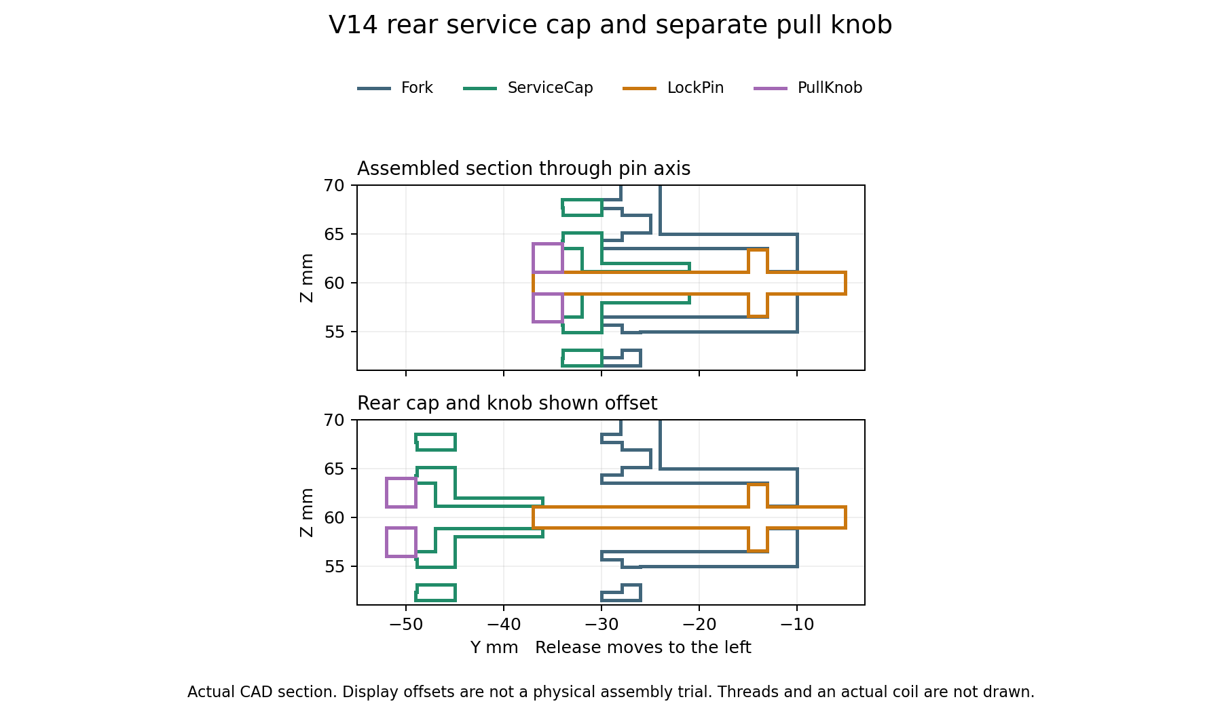
Sections through saved V14 CAD. Colours identify parts and do not select materials. The exploded offsets explain assembly; they are not a physical assembly trial.
The V14 adult small main fork fixture now has two completed meshes. Displacement changed by 1.07 percent and sampled peak stress by 3.05 percent. Both are within the chosen 5 percent comparison limit. This is a standalone component calculation, not a Sony pad or complete joint result.
The newer V14 box calculation makes the child carrying limit clearer: child small shrinks by less than 1 percent, while child medium and large become about 1 to 1.5 percent larger when folded. Adult examples shrink by about 12 to 23 percent. A clear folding path does not prove useful portability.
These changes belong to the standalone ear defender. They do not alter the Sony WH CH720N or validate its replacement pad. The original pad and mounting groove measurements remain deferred by the user. Its generic V8 cushion is unchanged. No new fit, glasses pressure, incoming noise, outgoing music, response or ANC pass is added.
Both reports share the same revision and limits. V14 is local STEP work; the newest native Fusion archives remain V10. The main project report contains the detailed new checks and retained failures. Earlier market prices remain a dated comparison, not a new quote or proof that our design is better.

V15 Knob retention experiment
V15 is one adult small retention pilot. It adds an intended M2 threaded metal knob and a separate hex jam nut to the V14 release stem. The earlier knob only had an unretained matching bore. Countertightening the nut against the knob gives us a defined retention method to develop. It has not passed pullout, loosening, repeated release or child access tests.
The knob is 8 mm across and 4 mm long. Its intended thread allocation is 3 mm, with a 1 mm rear counterbore. The separate nut is 4 mm across flats and 1.6 mm long. The male thread envelope is 6 mm long. The nominal nut to shoulder and shoulder to cap gaps are each 0.4 mm. These are design dimensions, not measured manufacturing tolerances.
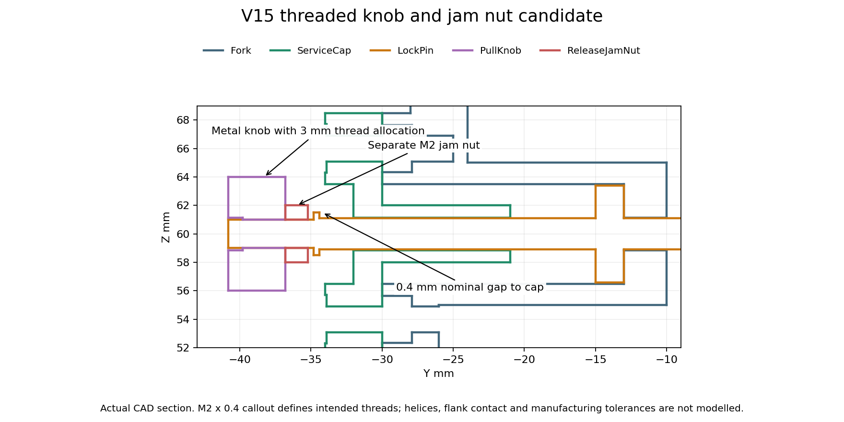
Exact section of the adult small pilot. The coloured outlines come from saved STEP geometry. Thread helices and flank contact are not modelled.
The saved pilot contains 46 solids. Its 6 recorded release and slider endpoint checks passed. These check geometric clearance outside the cosmetic thread allocations. They do not prove threaded engagement or a safe complete mechanism. No V15 six size motion pass or folding pass is inferred from them.
The intended thread is M2 with 0.4 mm pitch, using proposed 6g external and 6H internal tolerances. A Bossard technical guide lists these general tolerance fields and the M2 dimensions. A supplier drawing, thread runout, gauges, coating, final material grade, real wrench access and a controlled tightening process are still required. The smooth thread envelopes in the STEP file cannot replace these details.
Bossard metric thread dimensions and tolerances
This retention experiment belongs to the standalone ear defender. The Sony WH CH720N replacement cushion is unchanged. Its original mounting dimensions remain deferred by the user; fit, retention, pressure, incoming noise, outgoing music and ANC effects remain untested. The separate pad product does not inherit a benefit from this knob change.

V15 Shared packing and retention limits
Size | Boxes ranked | Endpoints checked | Best recorded fold against retracted unfolded
child small | 30625 | 65 | 0.51 percent larger
child medium | 30625 | 61 | 2.66 percent larger
child large | 30625 | 53 | 3.93 percent smaller

This search moves the existing V14 parts; it does not create a new child headband. It ranks 30 625 combinations per size using two slider positions from 0 to 30 mm and two cup angles from 0 to 120 degrees. Only a finite shortlist gets actual solid intersection checks. We stop at the first clear endpoint in that shortlist. Ranking boxes is not a collision pass or a proof of the best possible fold.
We compare the first clear new endpoint with the already checked V14 folded endpoint and keep the smaller recorded box. A worse new endpoint is rejected. The fully retracted unfolded baseline is included so that retracting the sliders cannot be presented as a folding benefit. These endpoint checks do not prove a new path to the pose. The original V14 sampled path evidence remains separate. The selected child packing goal is still unresolved.
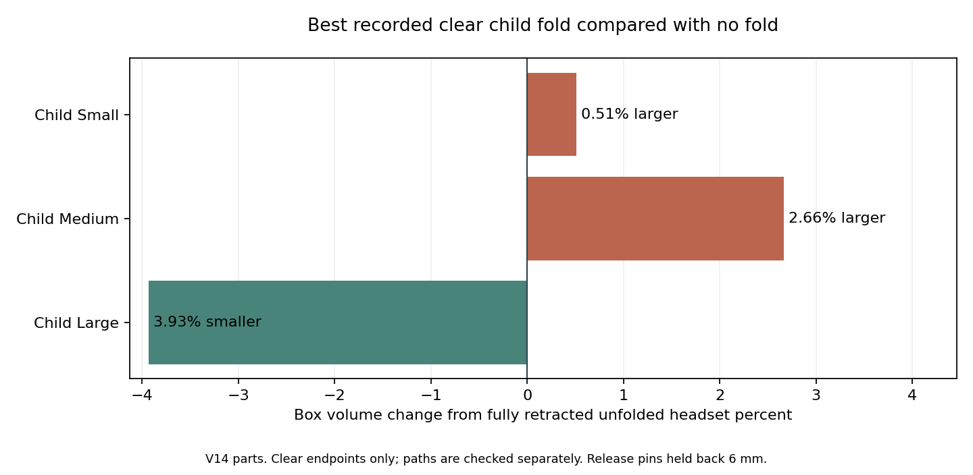
Source matched V14 clear endpoints are retained when the new search endpoint is worse. Positive bars mean more box volume than simply retracting the headset.
The fold search holds both release pins 6 mm back, as in the earlier V14 motion study. It does not show that a real spring would hold that state after we let go, or that the cups latch safely for storage. A stable released or folded storage mechanism remains a design task. A clear displayed fold is not yet a usable carrying mode.
The improved child large endpoint has 27 recorded adjustment, release and folding samples. The complete sampled sequence passed. With the headband fixed, the left slider goes to 0 mm and the right to 20 mm. Both release pins are held 6 mm back. The left cup turns 30 degrees first, then the right turns 60 degrees. This order is part of the checked sequence.
The exported box is about 247.0 by 81.6 by 171.1 mm. It is 5.24 percent smaller in volume than the nominal 15 mm slider pose and 3.93 percent smaller than the fully retracted unfolded pose. This is a modest geometric improvement for child large. Child small and medium still have no useful recorded improvement. The stable storage, pinch, physical handling and durability limits remain open.
The 2 new STEP reimports passed solid count, validity and volume checks. The improved child large export also matched the intended box dimensions. These checks cover storage of the geometry, not a physical product.

V15 Remaining retention and product tests
The retention screen calculates 72 assumed combinations of root diameter, tightening torque, nut factor and external pull. A simple solid rod model gives required yield strengths from 28.6 to 254.0 MPa for a chosen factor of two. This range is not an approved torque, material selection or thread strength rating. Thread stripping, real flank contact, stress concentration, actual jam nut load sharing, fatigue and loosening are excluded.
The new knob projects farther behind the cap and adds two separate small nuts to the headset. These changes can increase bulk and complicate assembly. The V14 folding results cannot be transferred to V15 without checking the new geometry. Child access to loose parts and pinch points remains open. We have not selected this retention pilot as a final product design.
At the V15 stage, V14 was the latest six size CAD candidate and V15 was a local STEP experiment for one size. The later V16 section records the next changes. Native editable Fusion archives remain V10. Real material data, complete joint analysis and physical comfort, acoustic and durability work are still needed.

V16 Indexed folding and rivet retention
Project status: V16 indexed folding candidates with V10 native archives.
V16 adds holes for the wearing and folded positions. The locking pins can return into the folded holes instead of staying held back. A recessed cross rivet retains each knob on its stem. This is an alternative to the longer V15 threaded knob and jam nut. It keeps the earlier 8 mm knob envelope, but servicing the pin means removing the rivet.
The selected child plate is a lower half disc with 16 mm radius and 3 mm thickness. Adult cups collided with this lower plate. The adult alternative puts a trimmed upper plate behind the guide and relocates the release housing. The child and adult fork arrangements differ and need their own strength checks.
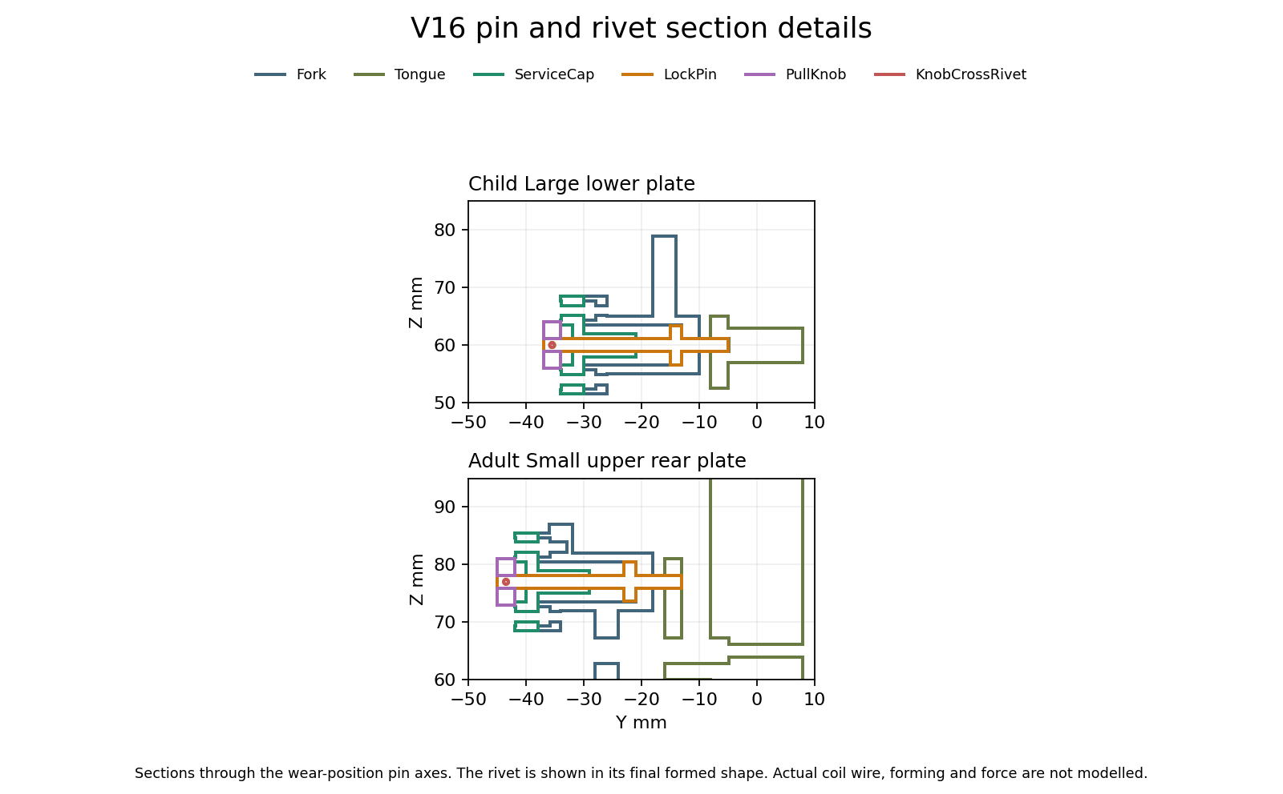
Actual sections of saved V16 wear-position geometry. Colours identify parts, not selected materials. A final formed rivet is drawn; the upsetting process and spring friction are not modelled.
The rivet shaft is 0.8 mm across, in a nominal 0.85 mm cross hole. Its formed heads are 1.2 mm across and sit in recesses. The knob bore is 2.3 mm around the 2.2 mm stem. These dimensions define positive geometric capture. Actual tolerances, metal grade, riveting tools, forming strain, wear and proof loads remain unqualified.

V16 Recorded checks and packing
Size | Sampled sequence checks | Folded box against retracted unfolded
child small | 39 | 4.88 percent smaller
child medium | 36 | 2.84 percent smaller
child large | 31 | 9.08 percent smaller
adult small | 39 | 1.61 percent smaller
adult medium | 42 | 14.60 percent smaller
adult large | 42 | 14.41 percent smaller

The six selected candidates have 229 recorded sequence samples, 276 solid-validity checks, 48 pin blocking queries and 36 rivet capture queries. The new plate query controls also use known embedded, disjoint and rotated test cubes. These are geometric checks, not force or durability results.
The sequences include slider movement, release, folding and pin return at the folded holes. At the indexed positions, an attempted one degree rotation produces pin to plate interference. Attempted rivet escape and knob withdrawal also produce interference. That supports the intended mechanical capture in rigid CAD. It does not measure holding force or prove that a spring reliably seats a real pin.
The 18 selected wear, released and folded engaged STEP exports passed independent reimport checks for solid count, validity and volume. Folded boxes were also compared with the audited poses. Native editable Fusion archives remain V10; V16 is local STEP work.
The packing figures compare a folded box with the same headset fully retracted and unfolded. They are not bag-fit or travel tests. V16 removes the held-release requirement in the checked geometry, but real spring return, finger clearance, stops outside the indexed positions and voluntary handling still need work.
Material selection still needs actual grades and samples. A BASF PA6 reference lists modulus 3500 MPa dry and 1200 MPa conditioned, with yield references 90 and 45 MPa. That is a large condition effect to account for in India; it is not a prediction for our exact weather or manufactured parts. A previously recorded POM reference is included for comparison.
BASF Ultramid B3S product data
The new screen records 45 nominal plate-load cases and 15 cross-drilled stem pull cases. The plate calculation uses bearing and a minimum-ligament proxy with chosen peak multipliers. The stem calculation uses its central remaining area and an assumed multiplier. Neither is a complete joint stress model or a qualified material rating.
Two published thin PORON battery-pad curves add more compression information than a single stiffness number. Only 12 of 36 assumed flat-area load cases fall within their published 20 to 70 percent strain range. We leave the other 24 without a predicted strain. These 0.85 to 3 mm grades cannot establish the behaviour of our shaped 20 mm cushion, cover, glasses seal or wearer comfort.
Rogers published compression curves
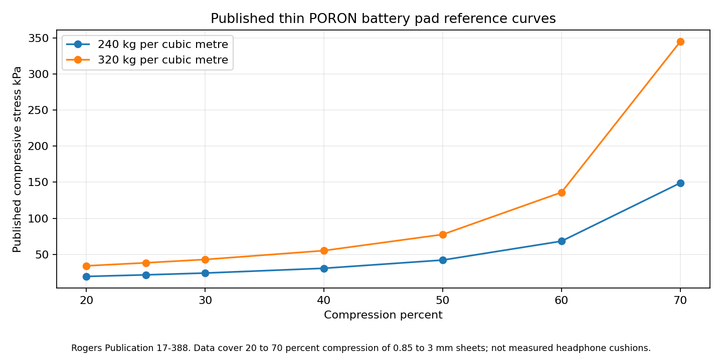
Manufacturer reference data for thin sheets. No low-pressure extrapolation or manufactured headphone result is claimed.
Seven blank CSV record templates are prepared for Sony measurements, foam and cover calibration, band and joint measurements, acoustic comparisons, wearer feedback, durability and supplier quotes. Their result cells are empty. The geometry quote BOM lists net CAD volumes and flags spring spaces as allocations that must not be priced or weighed as solid parts.
Draft durability screens include 5000 folding and slider cycles, 1 m drops in six orientations and 24 hours at 45 C and 85 percent relative humidity. These are proposed engineering targets to review before testing, not a standard, a completed test or a service-life claim. Real samples and instruments are still required.
Acoustic work must compare original and candidate seating with the same fixture and glasses frames. Incoming noise and outgoing playback are separate tests. For outgoing music, match measured internal playback level before comparing external sound and report uncertainty. No leakage or ANC benefit is established by CAD.
The Sony WH CH720N cushion geometry is unchanged. The user deferred its mounting measurements. The new standalone mechanisms do not qualify Sony fit, seal, pressure, frequency response or ANC behaviour. These remain separate entries in the shared test records.
No physical test has been performed in this update. Comfort and sensory acceptance require voluntary wearer feedback. Production cost requires real quotes including forming, tooling, assembly, inspection, scrap, packaging and distribution. The product remains a prototype candidate, with complete joint strength, actual materials, manufacturing tolerances and physical validation unfinished.

V16 Joint clearance and manufacturing errors
The 2.3 mm index hole and 2.2 mm pin leave only 0.05 mm of radial clearance. A nominal geometry pass is therefore not enough to establish reliable assembly or spring return. Both documents now record this manufacturing constraint; the CAD has not changed in this update.
Interface | Nominal radial clearance mm
Index hole and pin | 0.050
Cross drill and rivet shaft | 0.025
Knob bore and stem | 0.050
Rivet head recess and head | 0.050

The bounded-error screen records 600 index scenarios across six sizes and 100 other interface scenarios. Only 57 index scenarios retain a positive worst-case clearance. These are deliberately chosen error combinations, not random samples, supplier capabilities or a predicted factory yield. Losing a worst-case guarantee does not mean every real part fails.
A separate check on the saved solids ran 60 pin-to-plate offset queries. At both sides of all six sizes, 0.04 mm sideways offset stays clear and 0.06 mm produces interference, agreeing with the nominal radial clearance calculation. This checks only the wearing-position pin and tongue; it excludes the guide, cap, spring and actual manufactured surfaces.
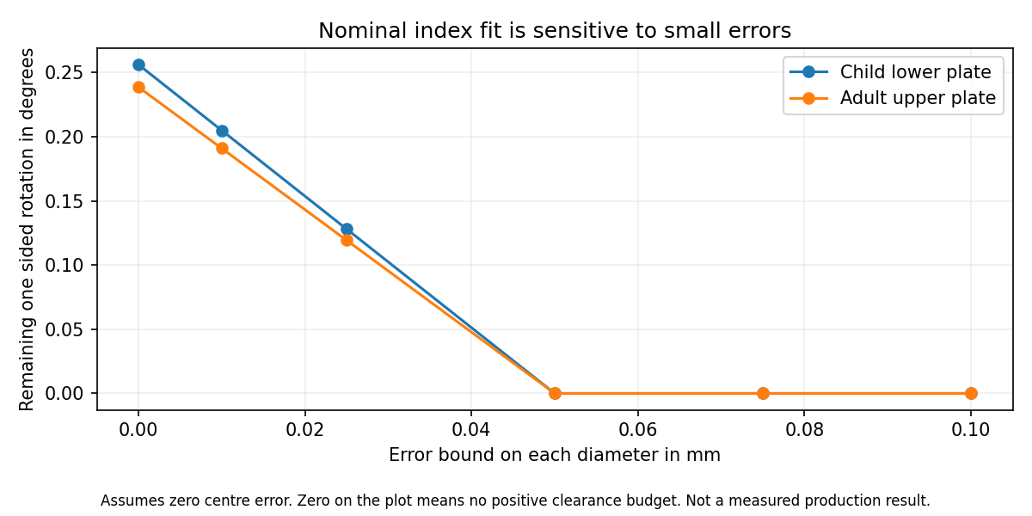
Calculated clearance budget with no centre error. The zero line includes contact and interference; it is not a measured performance curve.
With no dimensional or alignment error, the index clearance allows about 0.256 degrees of rotation each way for the child plate and 0.239 degrees for the adult plate before contact. This is only the index-hole contribution. Pivot clearance, guide play and elastic movement add their own effects.
For example, opposite diameter errors of 0.025 mm on both parts reduce the available radial clearance to 0.025 mm. A further 0.025 mm centre error uses all of it, even before angular error, surface roughness or swelling. The rivet cross hole has a smaller starting clearance and needs its own process decision.
The next mechanism change must balance easier pin entry against rotational looseness. Larger holes, an entry chamfer, a guided or compliant pin and tighter alignment control are candidates to compare. None is selected or qualified here. We still need real manufacturing capability, spring return force, friction, contamination and cycle measurements before approving tolerances.
These are standalone defender joint checks. The Sony replacement cushion has no such joint; its mounting measurements and physical seal tests remain outstanding.

V17 Pin entry trials
Project status: V17 two size entry pilots with V16 six size candidates and V10 native archives.
V16 exposed a small clearance budget at the locking index. V17 changes only the child large and adult small pilots. Their index holes grow from 2.3 to 2.5 mm. A 0.3 mm entry cone opens to 3.1 mm at the rear face. The straight bearing land becomes 2.7 mm long instead of 3 mm. The pin, cap, housing and spring space are unchanged.
Hole mm | Radial clearance mm | Child and adult play each way in degrees | Child and adult remaining margin mm
2.3 | 0.050 | 0.256 / 0.239 | -0.0945 / -0.0959
2.4 | 0.100 | 0.512 / 0.477 | -0.0445 / -0.0459
2.5 | 0.150 | 0.769 / 0.716 | 0.0055 / 0.0041
2.6 | 0.200 | 1.025 / 0.955 | 0.0555 / 0.0541

The comparison assumes opposite diameter errors of 0.025 mm on each part, a relative centre error of 0.1 mm and an angular error of 0.1 degrees, aligned unfavourably. These are chosen comparison inputs, not supplier capability or approved requirements. The 2.5 mm option is the smallest of the four tested diameters with positive margin in both layouts. Its remaining margin is only about 0.0055 and 0.0041 mm. It is an experiment, not an optimised final size.
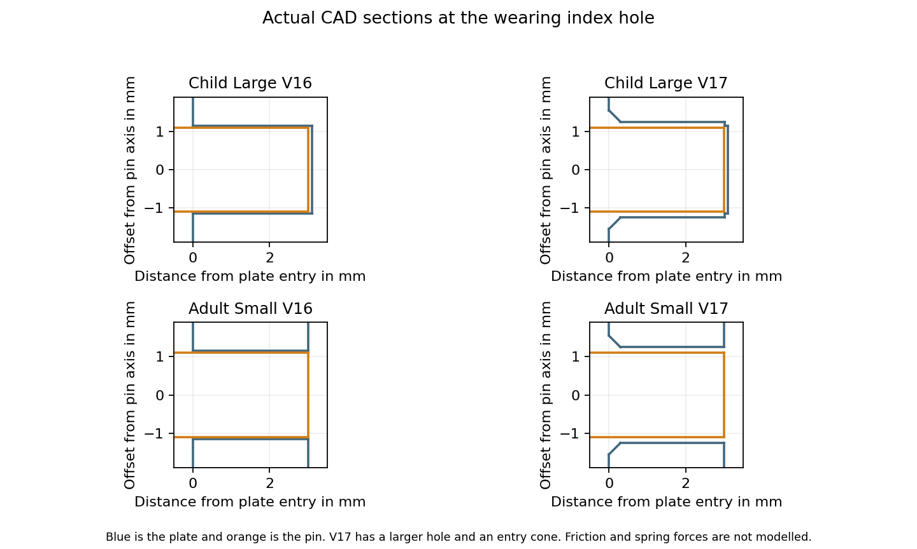
Actual sections through the wearing pin axes. The picture shows the local entry and straight land, not spring centering or a measured return force.

V17 Recorded geometry and component checks
Pilot | Sequence samples | Valid solids
child large | 31 | 46
adult small | 39 | 46

The two pilots passed 70 sampled adjustment, release, folding and pin-return poses. The records also include 16 attempted index rotations and 12 retention escape queries, which produced the intended geometric blocking. Both saved STEP files passed independent reimport and per-part volume checks. This is not a continuous motion, assembly-force or durability pass.
The 24 local entry queries agree with the intended geometry. A fully inserted pin with 0.14 mm sideways offset stays clear, while 0.16 mm causes interference. An offset tip can enter the wide mouth but then collide deeper in the cone or straight land. The chamfer does not by itself make a misaligned pin seat.
Separate tongue fixture | Fine displacement mm | Fine sampled stress MPa | Mesh comparison
child large | 0.5658 | 9.18 | Pass
adult small | 0.2408 | 27.61 | Pass

These are separate ideal component fixtures. Each stem is truncated and fixed at z 82 mm, with assumed modulus 2000 MPa and Poisson ratio 0.35. The assumed folded-hole load is 11.63 N for child large and 10.83 N for adult small. It acts only on the straight hole land. Straight-sided quadratic tetrahedra approximate curved surfaces with facets. The entry cone has no centering force or friction model. Mesh comparison and saved-array checks do not qualify the complete joint or actual material.
The wider hole triples the nominal radial clearance but also triples the index contribution to rotational play. The shorter straight land reduces the area available for bearing. The unchanged housing and cap still guide the stem through smaller clearances, and their alignment remains a separate constraint. We have not established real spring return, tolerance capability, wear, contamination resistance, pinch clearance or child access.
V17 has two local STEP pilots only. V16 remains the latest six size CAD candidate and native Fusion archives remain V10. Previous whole-headset and material screens do not automatically transfer to the changed plates. Physical sound reduction, wearer comfort, sensory acceptance, durability and cost remain unvalidated.
The Sony WH CH720N replacement cushion is unchanged. These pin-entry trials concern the separate standalone defender. Sony mounting measurements and actual fit, seal, pressure, leakage and ANC comparisons remain outstanding.

V17 Loaded pin contact and spring return
The latch is on hold for production. Unloaded geometry and component mesh passes do not establish reliable pin return when the joint carries a sideways load. The new calculation bends a 2.2 mm pin against two guides with a gap and elastic wall contact. It is a one plane beam model, not full three dimensional joint contact.
The guide surfaces were extracted from both saved pilot solids. In common local coordinates, the rear guide runs from y minus 32 to minus 21 mm, and the front guide from minus 12.999 to minus 10 mm. The folded hole load acts at y minus 6.35 mm. The assumed elastic modulus is 193000 MPa. Guide stiffness, clearance and external load are varied; their actual manufactured values are not known.
Ninety contact cases passed their force and moment balance checks. Controls include an exact overhanging beam example, reversed loading and three meshes for each layout. The selected mesh comparisons pass the chosen 5 percent limit. An initial mesh created a very short near duplicate interval and poor conditioning; accepted results use a corrected mesh split at each geometric boundary.
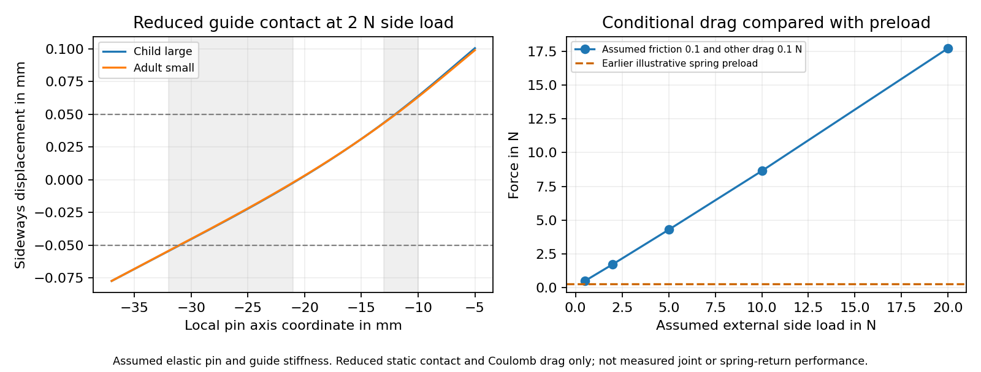
Reduced static contact and assumed Coulomb drag. The plot is a diagnostic calculation, not a measured return force or physical joint rating.
Chosen comparison at 2 N side load | Force N
Earlier illustrative spring preload | 0.290
Guide drag at friction 0.1 plus other drag 0.1 N | 1.864
Guide drag at friction 0.3 plus other drag 0.1 N | 5.391

The 1080 drag and preload comparisons have 180 positive assumed margins. That count is not a probability or a predicted factory yield. Sliding drag is estimated from static guide reactions; no actual withdrawal or return path, surface pressure, collar, cross hole or chamfer centering is solved. The result identifies a risk to measure, not a proven failure in a real product.

V17 Spring trade offs and completion decision
The 300 alternative spring designs vary wire diameter, coil diameter, active turns and free length. The screen also includes assumed dimensional errors, a 10 percent rate range, 1.5 mm permanent length loss, a 0.5 mm reserve above solid height and an approximate coil diameter increase. Typical 301 full hard wire data are a reference, not a manufactured spring allowable.
Ulbrich 301 wire reference data
Lee Spring design considerations
Sixteen designs meet the chosen envelope, static reference, return and pull criteria with zero guide friction. None meets them all at assumed guide friction of 0.1, 0.3 or 0.6 under the 2 N side load comparison. The 3 N pull limit is an illustrative engineering choice; it has not been approved by autistic users or established as a comfort or dexterity threshold. This finite search does not prove that every possible spring or latch architecture fails.
The spring CAD is still a space reservation. No actual coil ends, spring seating, lateral stability, fatigue or manufacturing process has been qualified. A coupled three dimensional joint analysis needs credible materials, friction, support stiffness, fasteners, torque and load requirements. Additional arbitrary simulations cannot establish those missing inputs.
Workstream | Current status | Evidence still needed
Six size geometry | V16 sampled checks pass | V17 is two pilots only; native Fusion remains V10
V17 component and reduced contact models | Chosen numerical checks pass | Complete joint and actual material correlation
Loaded spring return | Production hold | Measured pull, return, drag, spring rate and set
Headband and full worn fit | Conditional studies only | Actual clamp force, heads and contact materials
Foam cover and glasses zone | Reference screens only | Compression recovery, stretch, friction and actual frames
Sound reduction and outgoing leakage | No physical pass | Matched acoustic tests with repeated seating
Comfort heat and sensory acceptance | No physical pass | Voluntary feedback and climate measurements
Drop cycles cleaning and ageing | Not performed | Actual assembled samples and reviewed test loads
Sony WH CH720N fit | Measurements deferred | Original mounting dimensions and host comparisons
Manufacturing and final price | Not released | Process capability, assembly proof and supplier quotes

The package includes a 28 workstream completion matrix and blank measurement records. The recorded assessment is complete; the whole product is not. The next step is to measure pin return and guide drag with actual parts, then decide whether to change the spring, guide or latch architecture. Material calibration and Sony mounting measurements must precede model specific and physical performance claims.
The production hold above concerns the standalone latch. The replacement cushion remains a separate candidate and still needs Sony mounting measurements, calibrated pad materials and physical fit and acoustic tests.

V18 A different folding hinge
Project status: V18 six size passive hinge candidates with V10 native archives.
V18 is our latest six size local STEP candidate. It replaces the sliding locking pin with a passive friction hinge and a separate stop at the wearing angle. The old pin return problem is removed from this mechanism. A different set of questions now matters: actual hinge torque, stop strength, wear, creep and fastener retention. None has a physical pass yet.
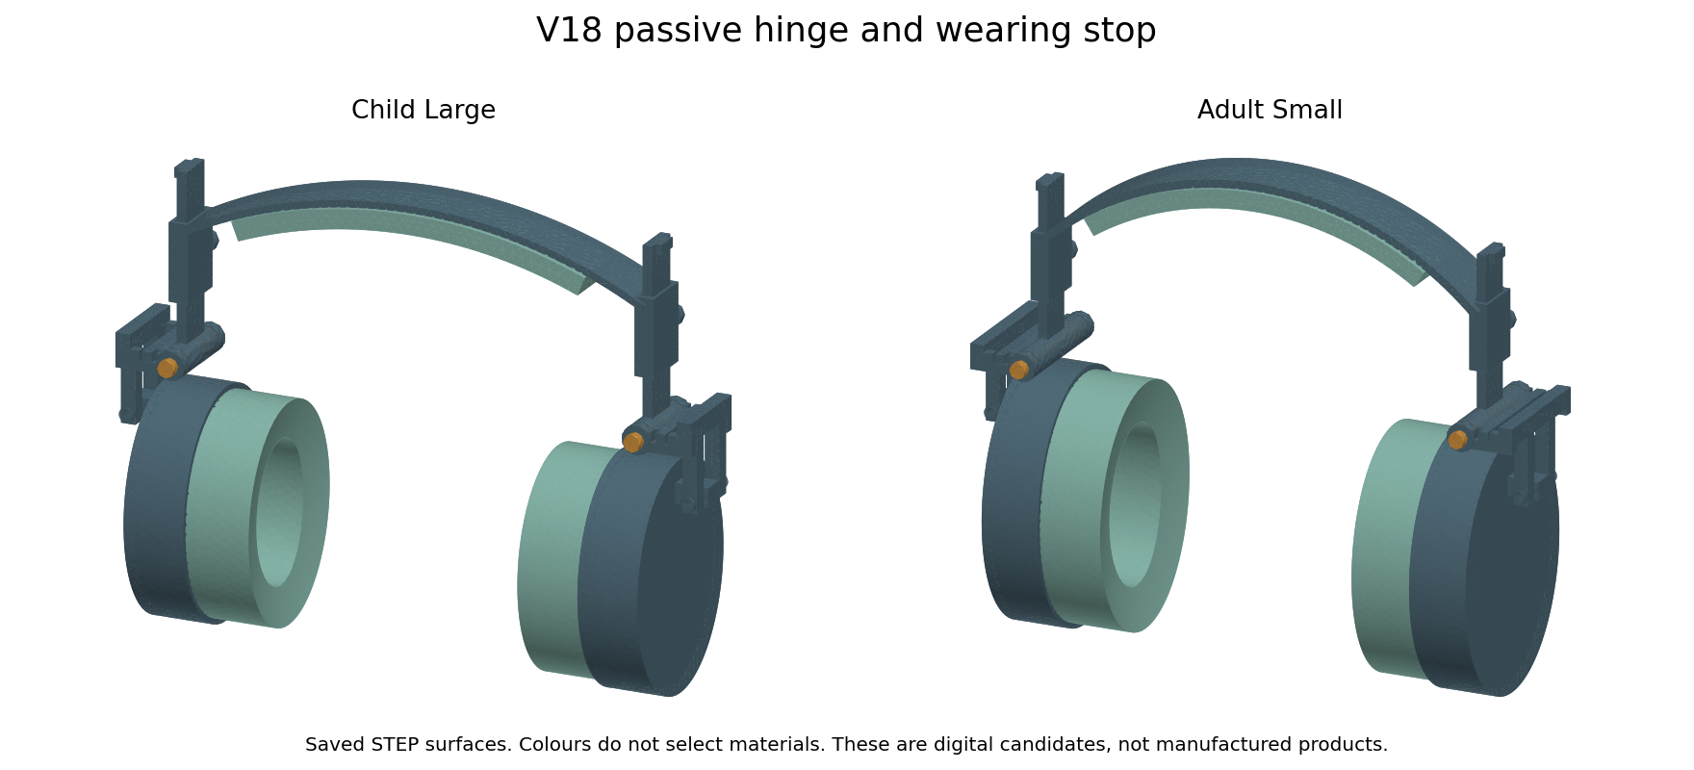
Actual child large and adult small STEP surfaces. Colours show parts, not chosen materials. Native editable Fusion archives remain V10.
The stop supports outward cup rotation at the wearing angle. Folding inward moves the fork away from that stop. Friction is intended to hold the chosen angle. This is not a positive lock against every load direction, and an inward force can still fold the cup. We must test unwanted folding and handling before calling it suitable for a wearer.
This change is for the standalone defender. The separate Sony WH CH720N pad is unchanged. Its carrier is still generic, and its mounting measurements are deferred. No Sony fit, seal, bass, ANC, outgoing leakage or glasses comfort pass is added by the hinge work.

V18 Geometry and rejected trials
Size | Pose samples | Retracted box mm | Folded box mm
adult large | 35 | 276.1 x 90.0 x 191.8 | 258.3 x 90.0 x 172.0
adult medium | 35 | 259.9 x 90.0 x 191.8 | 242.1 x 90.0 x 172.0
adult small | 32 | 243.4 x 90.0 x 191.8 | 229.3 x 90.0 x 194.6
child large | 26 | 242.6 x 77.2 x 181.1 | 239.7 x 77.2 x 171.9
child medium | 29 | 232.1 x 77.2 x 181.1 | 227.6 x 77.2 x 187.1
child small | 32 | 220.9 x 77.2 x 181.1 | 211.9 x 77.2 x 187.1

All six candidates have 38 valid solids. Together they pass 189 sampled rigid poses and 24 outward stop queries. Eighteen saved wearing, retracted and folded STEP files were independently reimported and checked for solid count, validity, volume and pose bounds. These checks do not establish continuous clearance under load, safe finger gaps or durability.
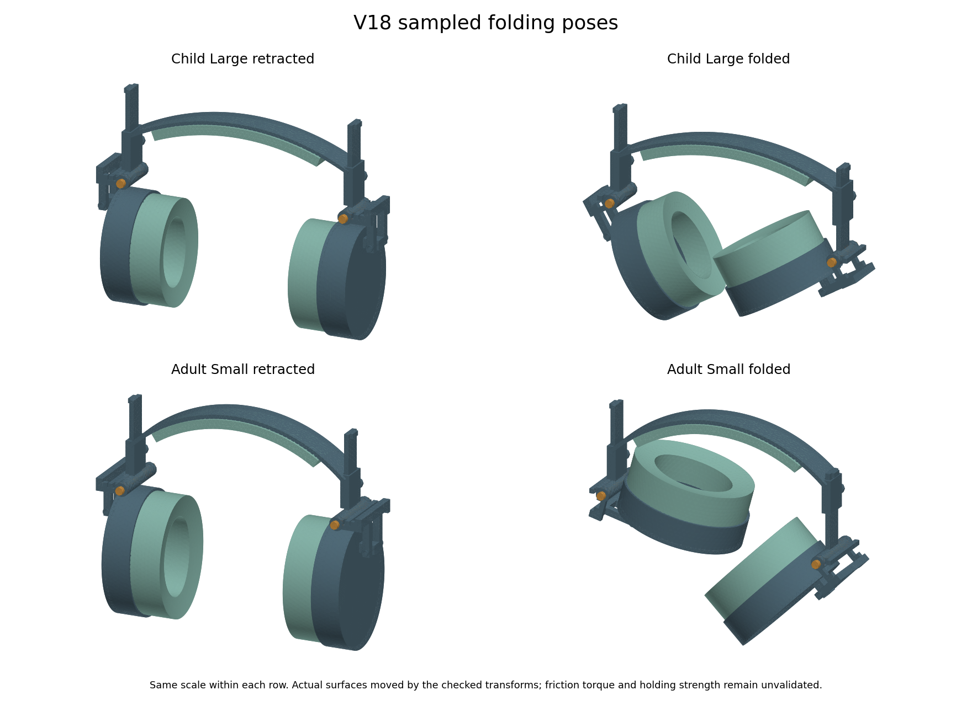
Actual saved surfaces moved by the checked transforms. Same scale within each row. Folding angles and slider positions differ by size.
The first stop relief collided after 5 degrees of folding. We retained that failed trial and widened the relief. The first adult layout also touched the cup shell; raising its hinge by 3 mm cleared the tested contact. Its guide bottom moved from z 82 to 85 mm to provide clearance at the shortest setting. The final rigid motion checks use these corrected parts.
Folding is available, but its packing benefit varies. The band and protruding sliders limit the envelope, and the smallest child version has only a small bounding box reduction. A box comparison is not a carrying test or an optimised travel design. The rigid surfaces also do not represent actual fabric texture.

V18 Torque and the wearing stop
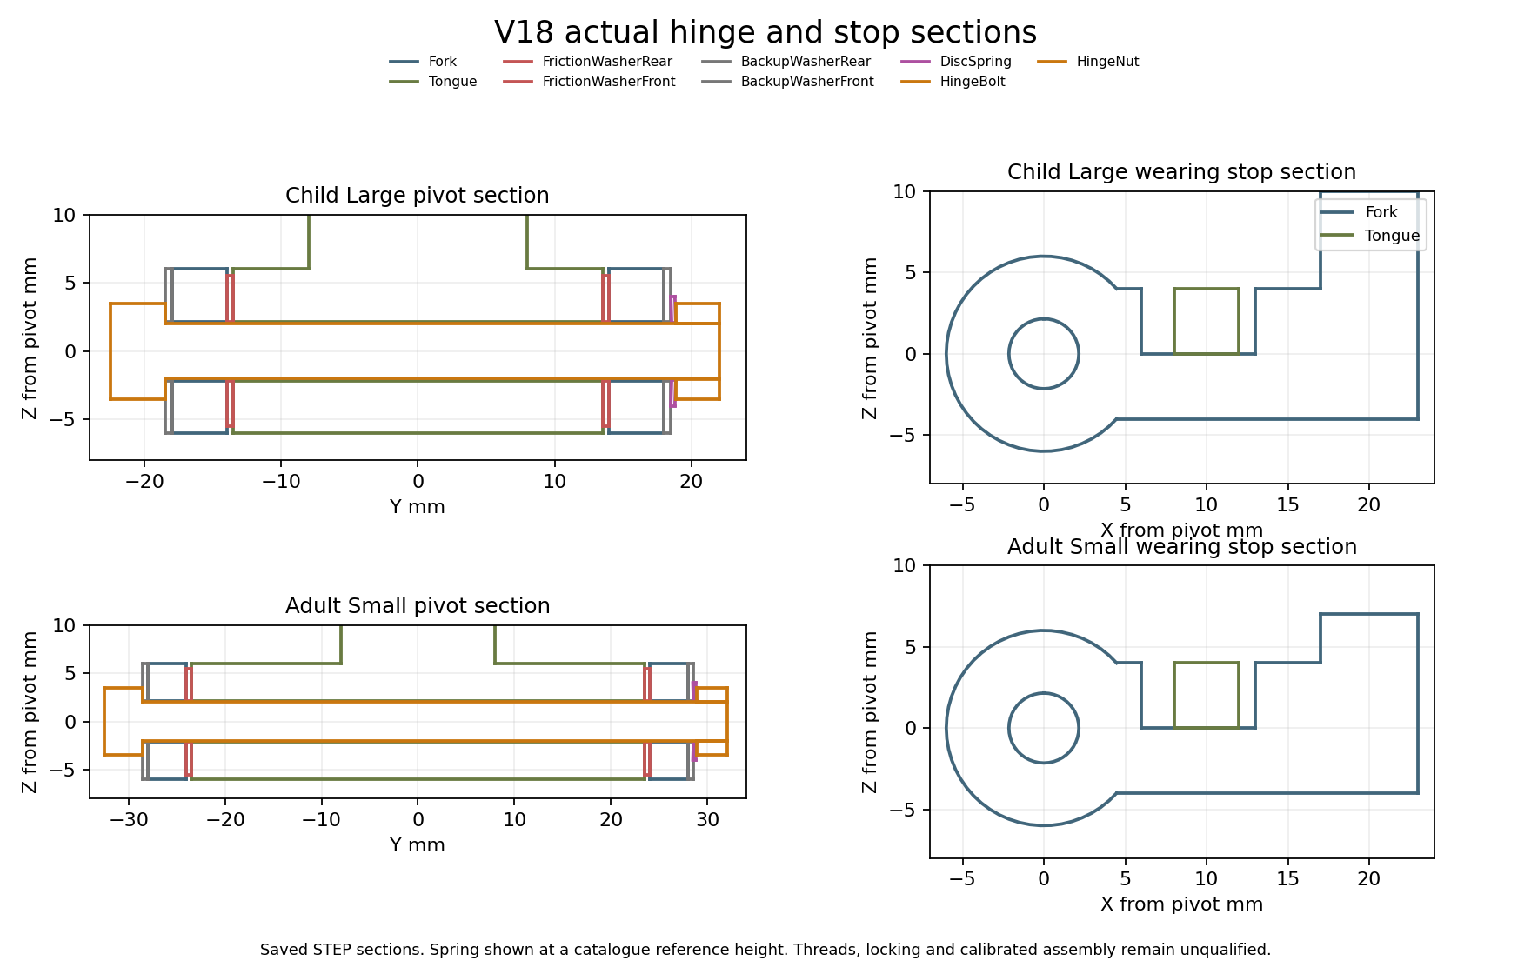
Sections of actual saved hinge and stop solids. The spring is at a reference catalogue height; the nut and bolt use thread envelopes.
Each hinge has two friction washers, backup washers, a disc spring, a bolt and a nut. The two stop patches total 32 square mm. The proposed spring reference is SCHNORR 000600 B, with 8 mm outside diameter, 4.2 mm inside diameter and 0.3 mm thickness. The catalogue gives a calculated force of 118 N at about 0.188 mm shortening. This is a reference point, not a purchased component or a measured preload.
SCHNORR manufacturer catalogue reference
A fixed nut position cannot guarantee the same hinge torque when friction changes. Our proposed assembly target is 80 Nmm with a chosen 20 percent window, or 64 to 96 Nmm. We would measure the hinge torque directly, adjust it and qualify a locking method. Tightening torque at the nut is not a substitute. No actual calibrated assembly has been made.
At a 65 mm grip lever the upper target corresponds to about 1.48 N; at 50 mm it is 1.92 N. These are engineering comparisons, not comfort or dexterity thresholds for autistic people. We have no spring force curve from which to infer the correct nut position or installed height. The CAD spring height therefore remains a catalogue reference pose.

V18 What the numerical checks mean
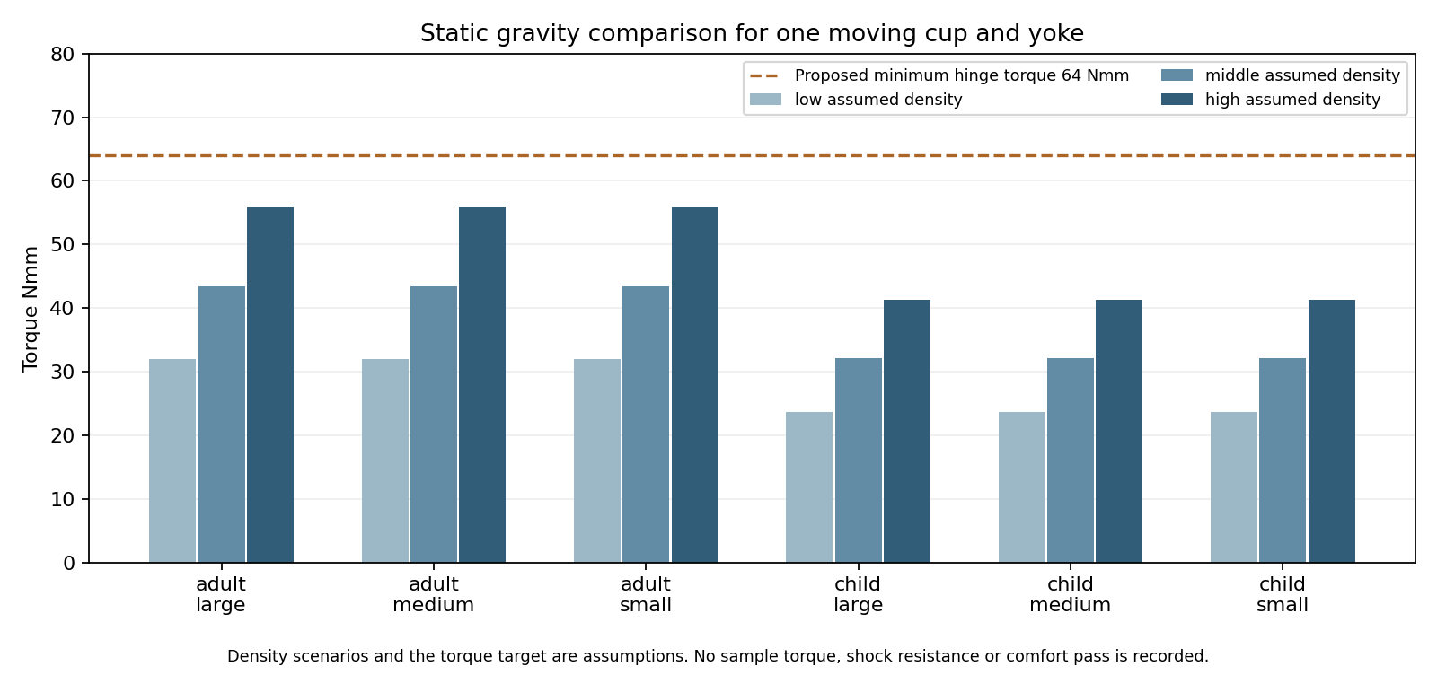
Maximum static gravity moment over orientation for each assumed density scenario. This is not a measured mass or hinge holding result.
The 18 density scenarios use the saved moving cup, pad and yoke volumes and centres of mass. Their largest calculated gravity moment is 55.77 Nmm, below the proposed minimum of 64 Nmm. With assumed friction from 0.1 to 0.3, the target preload falls within the comparison spring capacity. At friction 0.05 the comparison fails. We have not measured the friction pair, torque drift, shock resistance or resistance to accidental folding.
Ideal stop fixture | Displacement mm | Sampled stress MPa | Chosen mesh gate
child large | 0.1635 | 3.53 | Pass
adult small | 0.1787 | 3.78 | Pass

The stop fixtures apply a total of 13 N over both patches, representing an illustrative 2 N side force at a 65 mm lever and a 10 mm stop radius. Each stem is cut and fully fixed at the guide bottom. The assumed elastic modulus is 2000 MPa and Poisson ratio is 0.35. These separate fixtures omit actual pivot load sharing, guide contact, bolt preload and fork contact. They do not qualify complete joint strength.
The two tongue and fork shapes in each size family were checked for equal geometry after translation. That allows a listed component fixture to be shared within its family. A Boolean equality query did not establish child band identity, so we independently reran the band fixtures for every size instead of transferring an old result.

V18 Headband checks and the next decision
Band fixture | Guide movement mm | Sampled stress MPa | Last stress change
adult small | 2.798 | 2.52 | 3.78%
adult medium | 2.994 | 2.90 | 3.86%
adult large | 3.189 | 3.19 | 2.82%
child small | 3.473 | 2.41 | 0.99%
child medium | 3.679 | 3.47 | 0.12%
child large | 3.862 | 2.59 | 0.08%

Every band is loaded by 2 N at one guide end with ideal symmetry and crown datums. It is a separate elastic fixture with assumed modulus 2000 MPa and Poisson ratio 0.35. The selected final comparisons meet the chosen 5 percent displacement and sampled stress gates. The saved arrays also pass work and energy, force balance, fixed displacement, finite value, residual and positive element checks. Numerical datums do not model a real scalp, and sampled stress is not a material strength allowable.
Comparison | What V18 adds | What remains unknown
V17 sliding pin | Avoids the loaded pin return mechanism | Friction torque and stop retention need samples
Ordinary folding headphones | Six saved adjustable sizes and a proposed calibrated hinge | No better durability, comfort or size claim
Existing sensory earmuffs | Passive cup and soft zone concept with no generated audio | No measured attenuation or sensory acceptance advantage
Specialist glasses pads | Standalone pad learning can be shared | Sony mount and actual pressure and acoustic comparisons still needed

The digital prototype package is ready to guide the next experiments. The complete product is not finished or released for manufacturing. We still need actual foam compression and recovery, cover stretch and friction, selected structural materials, measured headband and hinge forces, assembled joint tests, drop and cycle tests, pressure and climate measurements, voluntary wearer feedback and repeated acoustic tests. Earlier finite material screens are not a test of every possible material.
For the Sony route, measure the original mount before making a model specific pad. Compare the original, a uniform new pad and our softer zone pad under the same measured conditions. No zero leakage, pain relief, universal fit, market superiority or lowest price claim is supported. Supplier quotes and verified production processes are still needed. Both reports retain the earlier results and failures and will be updated together when measured evidence is added.

V18 Final component checks
The fork between the cup and folding hinge now has its own component test. This adds evidence for a part that was missing from the earlier V18 fixtures. It does not replace the complete joint, worn fit or acoustic tests.
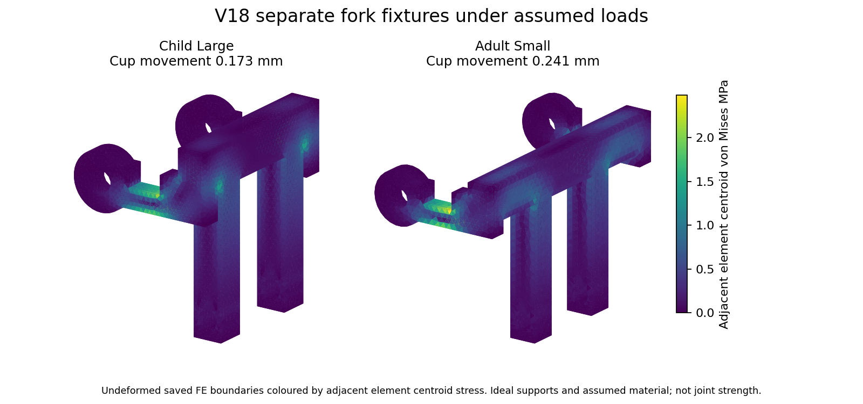
Actual saved finite element boundaries. Colours show adjacent element centroid stress on the undeformed fork; they are not measured surface stress.
Fork fixture | Cup movement mm | Sampled stress MPa | Last stress change | Chosen mesh gate
child large | 0.1727 | 2.49 | 2.37% | Pass
adult small | 0.2410 | 2.47 | 4.57% | Pass

The two pivot bore surfaces are fully fixed. A uniform total force of 2 N acts along X on the two cup pin bores. Downward forces of about 4.8 N in the child fixture and 5.4 N in the adult fixture act over the two stop patches. These loads balance the moment around the folding axis. They are a different load case from the earlier 13 N tongue stop fixture and must not be combined as if they solved one assembly.
The material is still assumed: elastic modulus 2000 MPa and Poisson ratio 0.35. Straight sided quadratic tetrahedra approximate the curved surfaces. Actual bearing pressure, bolt preload, washer friction, guide flexibility and stop contact are not solved. Numerical support reactions are not real pressure measurements.

V18 Testing decision and remaining inputs
The current V18 component assessment is recorded. There are now 30 saved solver array audits across the band, tongue stop and fork fixtures. Source hashes, work and energy, force balance, fixed displacements, finite values, residuals and positive elements were checked. A mesh comparison pass means that selected calculated outputs changed by less than our chosen limit. It does not mean that a real product passed a strength or comfort test.
The first child fork stress comparison exceeded the chosen 5 percent limit. A finer mesh was added and the final comparison is reported above. The earlier result remains in the evidence. Refinement was used to check this particular output, not to certify every local stress or remove the need for a physical test.
Work still needed | Input or test needed | Status
Complete joint contact and strength | Measured materials, friction, bolt preload and guide/pin support behaviour | Not established
Hinge torque drift and fastener retention | Actual assembled hinge and torque measurements | Not performed
Foam cover and structural materials | Actual grade-specific samples and compression recovery stretch creep friction data | Not validated
Worn force and pressure | Known head/fixture geometry and measured headband force and pad behaviour | Not validated
Incoming attenuation and outgoing leakage | Physical acoustic fixture or laboratory and repeated seating with and without glasses | Not performed
Heat humidity and sensory acceptance | Actual climate measurements and voluntary user feedback | Not performed
Durability and child handling | Reviewed loads, assembled samples, cycle/drop/cleaning/retention and pinch assessments | Not performed
Sony WH CH720N fit | Deferred original pad and mounting dimensions, then physical host comparisons | Not established
Final cost and production capability | Chosen processes, tolerances, supplier quotes and sample yield | Not established

The next useful step is a measured bench prototype, followed by corrected material models and assembled tests. We cannot honestly mark sound reduction, leakage, comfort, heat, fatigue or sensory acceptance as passed using the current unknown properties. Complete joint contact and manufacturing details also remain open. This is not a finished or released product.
The Sony WH CH720N pad still needs the original mounting dimensions, which the user will measure later. The fork results concern the separate defender. They do not add a model specific fit, glasses pressure, ANC or leakage result.

V18 Final material and clearance screens
This is the final bounded screen on the current V18 geometry. It adds 500 material and load comparisons, 288 pivot clearance scenarios and 216 equivalent acceleration comparisons. These are calculated scenarios, not 1004 physical tests. All six saved CAD candidates were also measured for the hinge stack. No real part or Sony headphone was measured.
Recorded material reference | Modulus MPa | Ideal load for the reference band movement N
TECARAN ABS grey | 1700 | 1.70
TECAFORM AH natural POM C | 2800 | 2.80
TECAMID 66 natural PA66 | 3500 | 3.50
TECARAN ABS natural ASTM | 2758 | 2.76
TECADUR PET natural | 3300 | 3.30
TECAPEEK natural | 4200 | 4.20
Makrolon 2458 PC | 2400 | 2.40
Moplen HP500N PP | 1480 | 1.48
301 stainless annealed reference | 193000 | 193.00
301 stainless full hard reference | 193000 | 193.00

The ten grade records come from the saved 14 October reference study. Their source links and date are retained in the CSV. We reused the latest band, tongue stop and fork results. At the same applied force, the ideal movement changes inversely with stiffness. At the same imposed movement, the force rises with stiffness. The table uses the movement produced by 2 N in the original 2000 MPa band fixture. It is not a measured force on a wearer.
The scaling keeps Poisson ratio at 0.35 for every reference and assumes the same linear elastic geometry and supports. The PP value is a flexural proxy. The steel references concern wire data, not qualified formed strip. We did not change full assembly mass or simulate actual creep, fatigue, anisotropy, cover or foam behaviour. No material winner or manufacturing allowable is established.
The nominal 4 mm bolt in a 4.3 mm pivot bore has 0.15 mm radial clearance. The screen varies diameter error, relative axis error and radial swelling or coating. 192 of 288 scenarios retain positive calculated clearance. This count is not a factory yield or reliability probability. The other scenarios show that chosen adverse error bounds can consume the nominal clearance; supplier capability remains unknown.
All six saved CAD stacks show a nominal nut height of 3.2 mm and no bolt tip protrusion beyond the nut. Moving the nut outward as the reference disc spring relaxes gives about 3.01 mm overlap between the nominal solid envelopes. This is not a thread engagement or bolt strength pass. Real thread ends, shoulder length, locking, tolerances and calibrated spring position still need an assembly design and proof.

V18 Retention result and end of screening
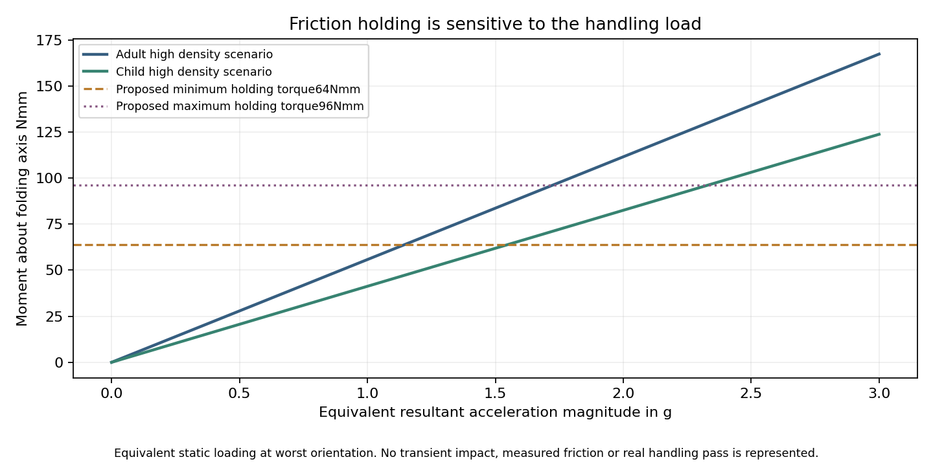
Calculated demand under equivalent static acceleration and the proposed unmeasured hinge torque targets. This is not a drop or impact simulation.
The earlier gravity check used one g. With the worst assumed moving mass and orientation, the proposed minimum torque of 64 Nmm is exhausted at about 1.15 g of equivalent resultant acceleration. Some 1.5 g scenarios therefore exceed that target. The hinge permits inward folding by design. Static gravity holding does not establish resistance to accidental folding during carrying or movement.
This is a risk found by a conditional calculation, not a measured failure of an assembled headphone. The calculation does not include a time history, inertia driven rotation, damping, friction changes or a retaining case. We need actual breakaway and running torque, ageing and handling measurements before choosing or changing the holding target. It would be misleading to call the headset durable or safely retained from these results.
Current evidence | Decision
Rigid CAD and saved poses | Recorded numerical checks completed
Band tongue and fork fixtures | Chosen component mesh comparisons completed under assumptions
Material clearance and retention screens | Completed finite scenarios with known limitations and retention risk
Complete joint contact and manufacturing | Still requires credible material contact and assembly inputs
Acoustics heat comfort and durability | Still requires physical measurements and assembled tests
Sony WH CH720N fit | Original pad and mount measurements are deferred

The available data screening is now recorded. The product validation phase has not passed. The next useful step is to select and measure actual material samples and make a bench assembly, then calibrate the models against it. More arbitrary inputs would not measure sound reduction, leakage, comfort or material life. There is no manufacturing release or demonstrated advantage over market headphones.
The Sony replacement pad geometry is unchanged. These standalone hinge and material comparisons do not prove that the replacement fits the Sony, reduces glasses pressure or preserves bass, ANC, isolation or outgoing leakage.

V19 Prototype assembly and next decision
Project status: V19 six size assembly prototype with conditional joint calculations and V10 native archives.
V19 keeps the six adjustable sizes and changes the hinge hardware. Each hinge now has two nested disc springs, a longer proposed pin and a second nut. The final local STEP assemblies contain 42 solids each. The current geometry is a prototype for review. Native editable Fusion archives remain V10. No physical material, sound, comfort or durability test has been performed.
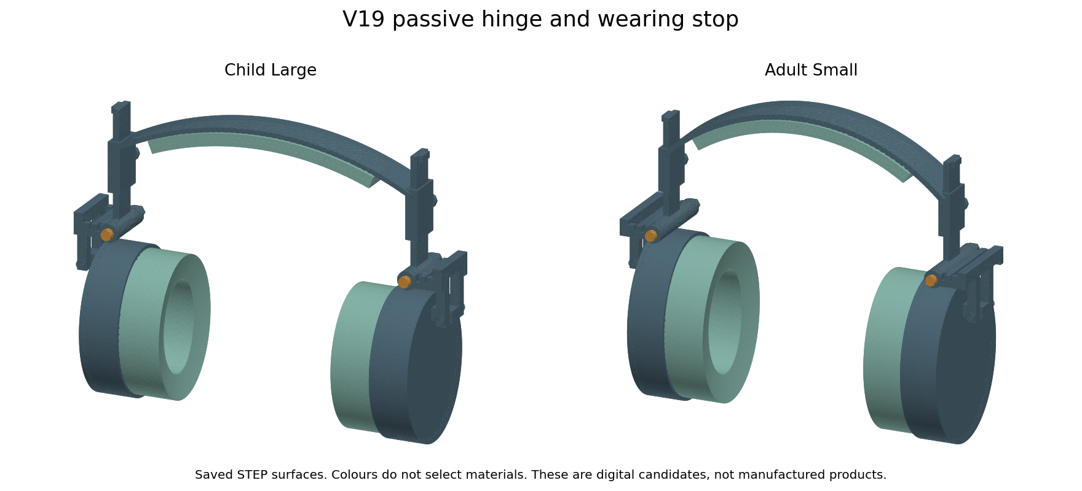
Actual final V19 STEP surfaces for child large and adult small. Colours identify parts and do not select materials.
The exact helical thread experiment was rejected. A validity check initially passed, but the pin contained two disconnected solids and the Boolean operation lost its core. We kept the failed trial and excluded it from the final assemblies. Current fasteners use cosmetic thread envelopes and proposed M4 x 0.7 drawing callouts. Thread strength, drive, runout, tolerances and effective locking still need supplier and bench review.
This hinge change belongs to the standalone defender. The Sony WH CH720N replacement pad is unchanged. It has no model-specific fit or sound pass. The shared material and measurement findings below apply to both routes.

V19 Folding and holding tradeoff
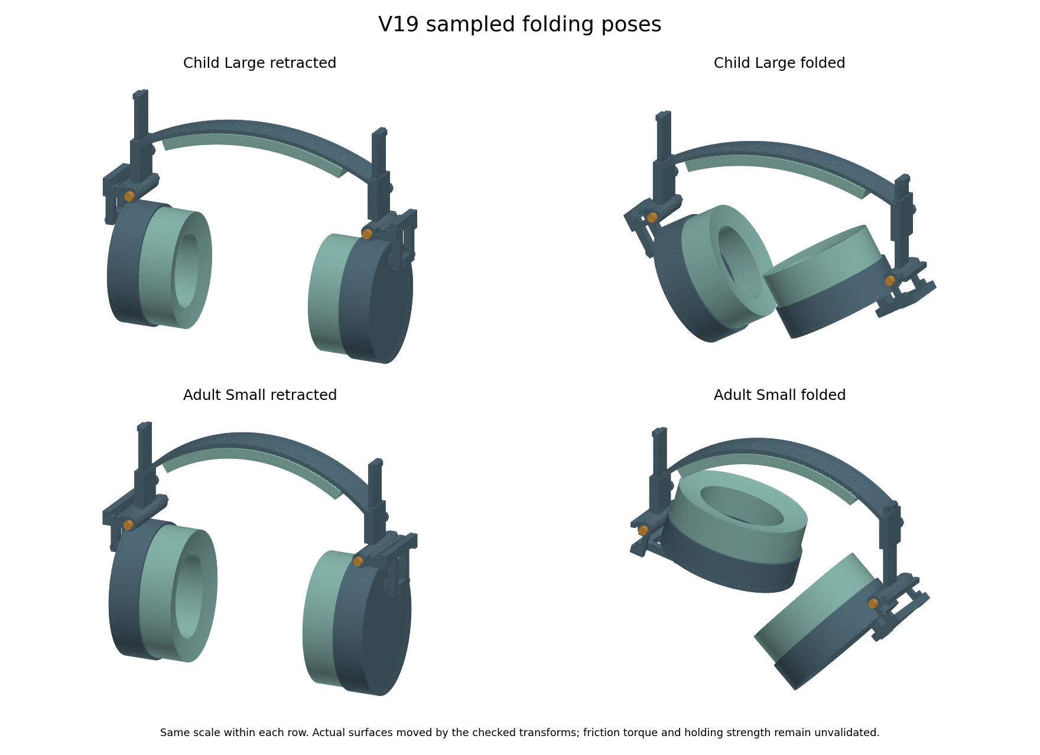
Saved V19 retracted and folded surfaces. Sampled collision checks do not establish continuous motion clearance, wrench access or handling strength.
The revised geometry has 189 recorded rigid pose samples and 24 outward stop queries across six sizes. The 18 saved wear, retracted and folded pose exports were separately reimported and checked. These are geometry checks, not wear or fatigue tests.
Prototype hinge detail | Nominal proposal
Plain pin diameter and pivot bore | 4 mm and 4.3 mm
Child pin underhead and plain shoulder | 45 mm and 37 mm
Adult pin underhead and plain shoulder | 65 mm and 57 mm
Thread callout and length | M4 x 0.7 for 8 mm; cosmetic CAD thread
Primary nut and jam nut heights | 3.2 mm and 2.2 mm; both 7 mm across flats
Nominal pin tip beyond both nuts | 1.9375 mm before tolerances
Disc pair reference height and force | 0.6625 mm and 236 N at catalogue reference shortening

Two nuts are proposed for countertightening while holding the primary nut. We still need to prove access with real tools and remeasure hinge torque after locking. The disc reference position is not a measured assembly setting. A nominal radial clearance budget leaves 0.06 mm after chosen diameter, axis and growth errors. Supplier capability has not been demonstrated.

V19 Retention and folding effort
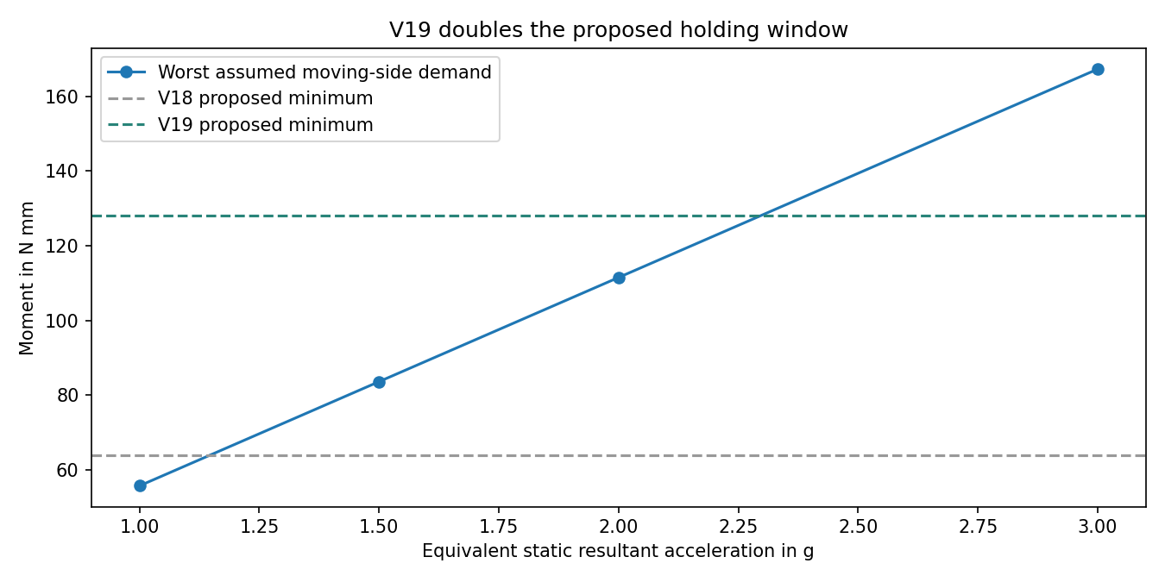
Equivalent static moment comparison. The torque lines are chosen targets, not measured hinge properties. This is not a drop or shake simulation.
The proposed target rises from 80 to 160 Nmm, with a chosen 128 to 192 Nmm comparison window. This doubles the earlier target and gives a worst assumed equivalent static threshold of about 2.30 g. All 18 assumed mass cases fall below the proposed minimum at 2 g. At higher acceleration some exceed it. The calculation inherits V18 moving cup and fork masses, which are unchanged; it does not predict impact dynamics.
At a 65 mm grip lever, that window corresponds to about 1.97 to 2.95 N folding force. More holding torque also means harder folding. We have no sensory acceptance limit for this force. Measure breakaway and running torque in both directions, then check drift after bedding, humidity, temperature and cycling. The higher target does not prove that the hinge will stay closed in a bag or stay comfortable to use.
SCHNORR describes parallel stacks as adding force at the same deflection. Our two-disc reference is based on its 000600B data. Real spring variation, friction, settling and plastic creep can change the assembly. Set torque by measurement, not by copying a nut position from the drawing.
SCHNORR disc spring stacking guidance

V19 Coupled joint calculation and limits
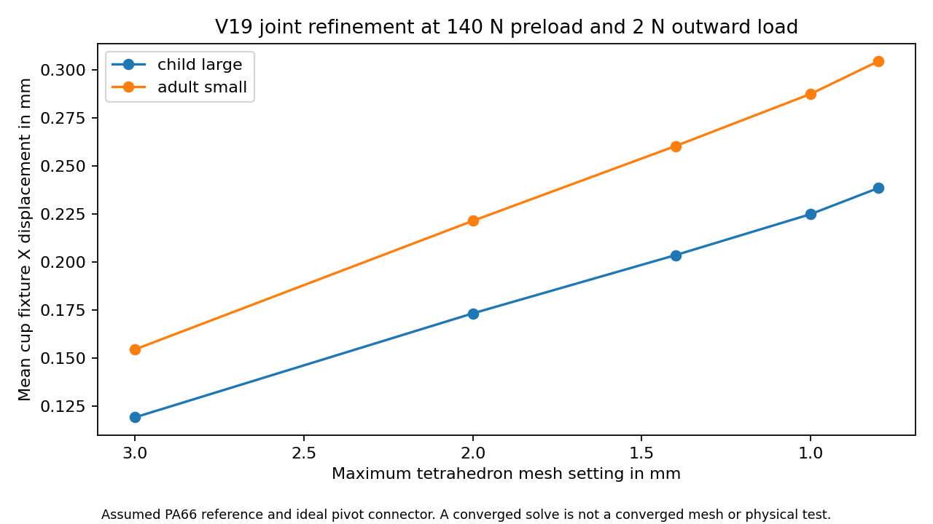
Solved displacement at the chosen outward 2 N fixture load. This model is a numerical development study; the final refinement result and gate are stated below.
We added a three dimensional calculation with flexible fork and tongue, one-way stop contact, washer contact and friction-limited tangential springs. There are 22 current cases: 22 converged and 0 did not converge. These counts describe numerical solves, not physical passes. Earlier low-preload low-friction runs reached the 80 iteration limit. Their failed records are retained alongside the later retry results. More iterations can fix an iteration-limit failure without proving physical holding or strength.
The model applies a prescribed preload and uses an ideal distributing pivot connector. It does not resolve real pin bearing clearance, bolt bending, thread load, disc spring deformation, guide contact or the full worn headset. The reference elastic modulus is 3500 MPa for TECAMID 66 natural and Poisson ratio 0.35 is assumed. This is a reference material calculation, not a qualified part grade or a prediction of long-term performance.

V19 Joint convergence and scope
Family and mesh change | Displacement change | Chosen 5 percent comparison
child large 3.0 to 2.0 mm | 45.5% | Fail
child large 2.0 to 1.4 mm | 17.5% | Fail
child large 1.4 to 1.0 mm | 10.5% | Fail
child large 1.0 to 0.8 mm | 6.0% | Fail
adult small 3.0 to 2.0 mm | 43.3% | Fail
adult small 2.0 to 1.4 mm | 17.6% | Fail
adult small 1.4 to 1.0 mm | 10.4% | Fail
adult small 1.0 to 0.8 mm | 5.9% | Fail

Reassembled equations, saved array comparisons, force balance, source hashes and a constant-strain control pass for 22 saved solves. These checks find algebra and file problems; they do not validate the physical model. Mesh results that miss the chosen limit are not hidden or promoted to a strength pass. There is no complete joint or whole-headset strength qualification.
The finest requested mesh in this run is 0.8 mm, with a chosen limit of 30000 nodes. A memory snapshot during the adult refinement showed about 1.3 GB free on the 16 GB laptop. This is a bounded study limit, not a proven hardware maximum. Further joint refinement or a different solver remains computer work if the numerical limit is not met; it is not being relabelled as completed physical testing.

V19 Material finding and prototype records
We checked additional published foam reference points rather than inventing a winning new material. PORON 4701-30 lists typical 25 percent compression pressures of 21, 35 and 62 kPa for its three density options. Under ideal uniform compression across our full annulus, those points imply the forces below. They do not provide a full loading and unloading curve for our pad.
Reference density | Child annulus force at 25 percent | Adult annulus force at 25 percent
240 kg per cubic metre | 64.6 N | 89.5 N
320 kg per cubic metre | 107.7 N | 149.1 N
400 kg per cubic metre | 190.9 N | 264.2 N

These ideal forces are much greater than the earlier 2 N per cup screening load. A material called very soft may still be unsuitable as a whole cushion at the required compression. This is a reason to request real samples and curves, not a comfort rejection based on one point. Supplier sheet thicknesses also do not automatically provide our full pad depth. We have not selected this foam or demonstrated its cost in India.
Rogers PORON 4701 30 data sheet
The handoff folder now contains CAD part envelopes, key dimensions, a nominal dimension-review PDF, assembly notes, blank material and test records, a Sony measurement form, a supplier quotation form and a measured-input readiness checker. No supplier was contacted and no quotation was obtained. The PDF is a prototype dimensional review, not a complete production drawing. Inputs remain blank because we have not measured a real sample.

V19 What we can conclude now
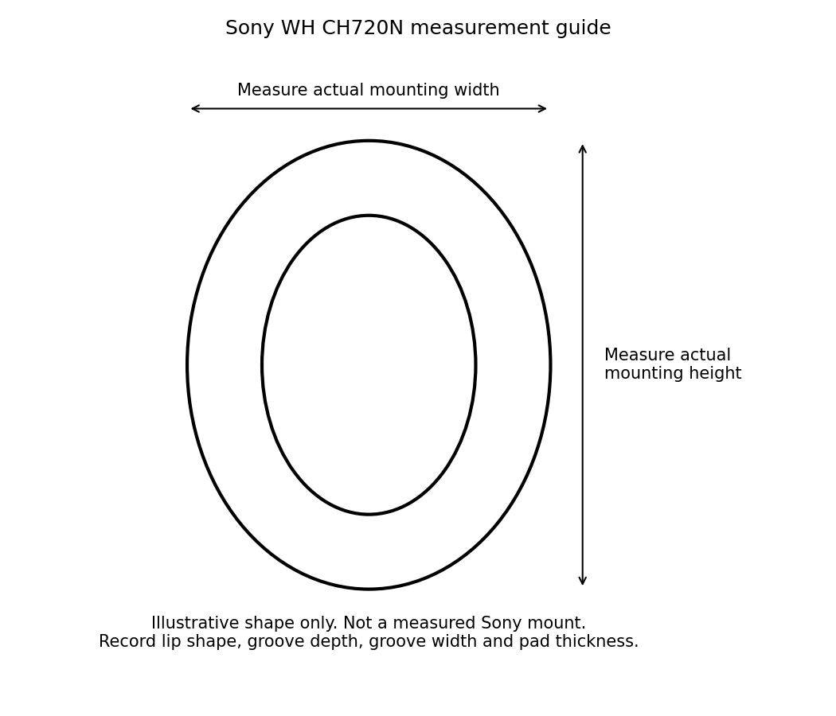
Measurement guide only. The pictured oval is illustrative and is not the Sony mounting shape.
Workstream | Current decision
Six sizes adjustment folding and saved STEP poses | Recorded finite geometry checks completed
Component band tongue and fork fixtures | Earlier conditional numerical checks retained
Coupled 3D joint | Development model; see failed solves and refinement limits
Full worn foam cover and skin contact | Not calibrated or validated
Real acoustics heat durability and sensory acceptance | No product validation pass
Sony WH CH720N compatible carrier | Original pad and mount measurements still required
Native editable Fusion update | Current native archives V10; V19 is local STEP
Production tolerances final materials and cost | Supplier and sample evidence still required

The computer package is a traceable prototype handoff. It is not evidence that every possible computer analysis is finished. A full validated worn model, exact Sony fit and production release are still open. More arbitrary simulation inputs cannot prove comfort, sound reduction, zero leakage, sensory acceptance or that we outperform market headphones. Earlier reduced contact, acoustic and thermal models remain exploratory.
Next collect actual foam and cover curves, hinge torque and headband force, plus the original Sony mounting dimensions. Build a bench hinge and pad sample, compare measurements with the models, then revise the CAD and make a complete fixture prototype. Voluntary wearer feedback is needed before any claim about autistic users. Both living reports must continue to update together when real measurements or new revisions arrive.

V19 Higher order joint model
The first linear solid joint model still changed by about 6 percent at the finest mesh comparison. A separate model variant aligns the washer boundary and preload footprint with the mesh, then uses quadratic solid elements. Its contact faces are split into small linear triangles. This improves the bulk bending approximation; it is still the same ideal pivot and prescribed preload concept, not a real bolt or complete worn headset.
We kept the earlier 8 washer boundary pilot cases and all 22 original joint cases. The pilot made little difference to the linear solid result. The new quadratic variant has 4 nominal outward fixture cases, comparing 3 mm and 2.3 mm settings for child large and adult small. The later inward extension is recorded in the next chapter. Other friction settings were not repeated with quadratic solids, so these results do not replace every earlier load case.
The first adult mesh had a curved cell that folded inside out, so we rejected it. The retry adjusts the high order mesh and retains the failed log. Accepted meshes must keep positive local cell volumes, checked through their Jacobians. The reference fixture uses 140 N preload, assumed friction 0.2 and 2 N outward load. This is not a measured setting for the proposed 160 Nmm hinge target.
Family | Mesh displacement change | Chosen 5 percent comparison
child large | 0.39% | Pass
adult small | 0.41% | Pass

The element controls reproduce a constant strain and its analytic strain energy on a straight tetrahedron. The volume and matrix symmetry controls also pass. Each element uses 27 positive integration points. Saved displacement, contact force, friction, force balance and source hashes were rechecked for 4 solves. The mesh volumes differ from the reference CAD component volumes by less than the chosen 1 percent check.
A passing displacement comparison applies only to this selected outward fixture, these two meshes and the assumed material and contact laws. It does not prove convergence for every stress, load, friction value or hardware part. Stress is sampled at element centres. Actual friction, bolt and bearing behaviour, material conditioning, creep and a full worn model remain unvalidated. The earlier failed mesh comparisons and iteration-limit trials are preserved.
The digital record now separates numerical verification from physical validation. We can use the assembly as a bench prototype proposal, while collecting actual material curves and joint measurements for calibration. Exact Sony fit, real sound reduction, music leakage, heat, durability and sensory acceptance still need the measurements and sample tests listed in both reports.

V19 Inward joint load comparison
We extended the higher order joint calculation to a 2 N inward load. The four cases reuse exactly the saved child large and adult small meshes from the outward study. The assumed PA66 elastic reference, ideal pivot, 140 N prescribed preload and friction coefficient 0.2 are unchanged. The CAD geometry is unchanged. These are separate static equilibrium cases, not a load reversal sequence or a cycling test.
Family | Mesh mm | Mean X motion mm | Stop force N | Iterations
child large | 3.0 | -0.2798 | 0.000 | 31
child large | 2.3 | -0.2808 | 0.000 | 33
adult small | 3.0 | -0.3494 | 0.000 | 61
adult small | 2.3 | -0.3506 | 0.000 | 61

Child large displacement changed by 0.37 percent between these meshes. This passes the chosen 5 percent comparison.
Adult small displacement changed by 0.34 percent between these meshes. This passes the chosen 5 percent comparison.
4 cases converged and 0 did not. Saved-array reassembly, source hashes, CAD volume and force-balance checks passed for 4 accepted solves. Negative X motion describes direction; it is not evidence of a comfort benefit.
The new inward cases extend the numerical record. They do not establish convergence of local stress or qualify the bolt, bearing, friction across different materials, long-term retention or the full worn headset. The spring torque target remains uncalibrated. This does not prove the proposed hinge stays closed during a drop or bag transport.
The Sony WH CH720N replacement cushion is unchanged. No model-specific fit, pressure, sound isolation, playback leakage or ANC pass is added. Real pad and mounting measurements, material curves and fixture measurements remain the next inputs for both product routes.

V20 Internet dimensions and cushion candidates
Update on 21 October 2026. We can start buying small test samples, but both products remain unproven. SoftSpace keeps its V19 headphone design. SoftSpace Flex now has three V20 pad body candidates based on a published compatible-pad size. They are not yet fitted Sony replacement pads.
Brainwavz lists a WH CH720N compatible pad at 100 mm high, 80 mm wide and 30 mm thick. Sony confirms a groove attachment with top and bottom alignment features. Neither source gives us a complete mounting drawing. We did not measure the user headphone or infer exact dimensions from an unscaled picture.
Actual saved V20 STEP surfaces. The two cutaways hide the cover to show different soft zones. The finished concept keeps a continuous cover. Colours identify parts, not selected material grades. Display triangles are not fabric texture.
Input | Value and evidence
Outside size | 100 by 80 by 30 mm from an aftermarket pad maker, not a Sony OEM drawing
Ear opening | 50 by 70 mm assumed for the first comparison
Cover thickness | 0.35 mm assumed; actual cover stiffness and seam need samples
Candidates | Uniform control, 18 mm soft zone and 32 mm soft zone
Attachment | Groove approach verified in Sony instructions; exact skirt and groove dimensions remain unknown

All three exported STEP bodies reimported with positive volumes and the expected part counts. This is a file and geometry check, not a mounting, sealing or comfort pass. The earlier generic V8 cushion remains in the history.

V20 What the cushion calculations show
We compared 11,664 paired cases with different assumed foam stiffness, cover stiffness, force, glasses thickness, position and zone size. This simple model treats areas of foam as separate compressible columns. It does not simulate a complete head, skin or real cover membrane.
Soft zone height | Paired cases | Cases with increased local pressure within the chosen compression screen
12 mm | 2916 | 624
18 mm | 2916 | 0
24 mm | 2916 | 0
32 mm | 2916 | 0

The 12 mm zone produced 624 cases with slightly increased pressure. The largest increase in the screened cases was 3.76 percent. A glasses arm that misses a soft patch can lose the intended benefit. The 18, 24 and 32 mm zones had no increases in this finite scenario set; this does not cover every face or glasses shape.
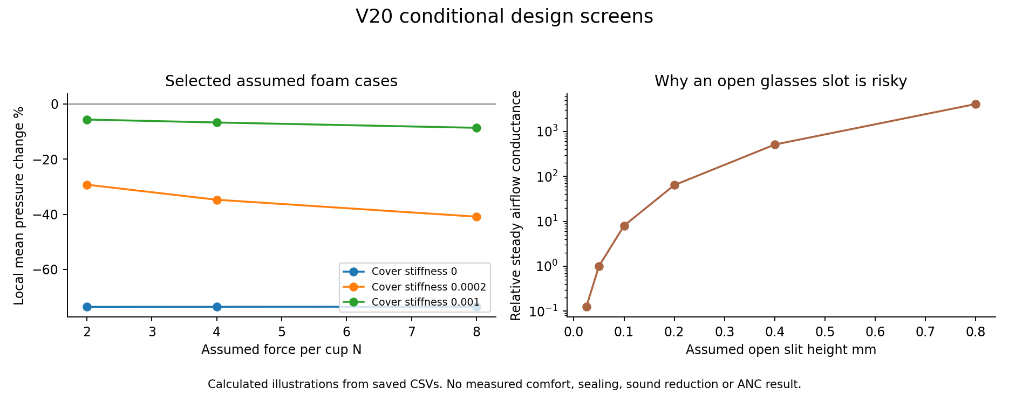
Left: selected pressure calculations show how an assumed stiffer cover can reduce the benefit of a soft insert. Right: a steady-airflow illustration shows sensitivity to an open gap. Neither plot is measured comfort, sound attenuation or ANC.
438 cases exceeded our chosen 40 percent compression screen and are flagged, not accepted as reliable high-compression predictions. The remaining 11,226 cases are still conditional calculations. No percentage here is a probability that a product will work.
Twelve selected rows were checked by a separately written scalar calculation with exact ellipse-strip areas. All stayed within the chosen 1 percent comparison. Force balance and a uniform-pressure reference also passed. These checks support the implementation, not the realism of its assumed material law.

V20 Headphone checks and remaining risks
All eight saved V19 higher-order joint solutions passed a fresh equation reassembly, file hash, force-balance and saved-array audit. This repeats the same model rather than using an independent physical experiment or a different joint solver. The original V19 assumptions, failed routes and limited stress sampling still apply.
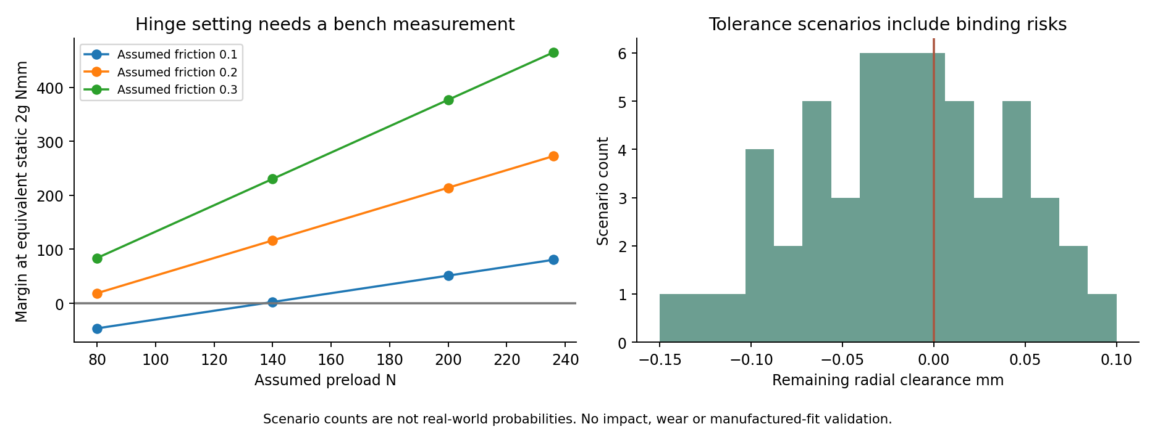
V19 geometry with new assumed friction, preload and tolerance combinations. Negative values identify scenarios that need a controlled setting or a better fit. Counts are not reliability statistics.
5 of 36 assumed hinge combinations had a negative holding margin. 33 of 54 assumed fit combinations used up the available clearance. We therefore recommend a bench hinge and a pin fit sample before ordering a complete headset.
The prior proposed clearance allocation still leaves 0.06 mm radial margin if its tight assumptions are achieved. That is a requested prototype condition, not evidence that a printer or supplier can achieve it. Measure the finished bore, pin and alignment before assembly. The proposed hinge torque needs direct measurement after locking the nuts.
Full worn contact, calibrated foam and cover behaviour, incoming sound reduction, outgoing music leakage, ANC, heat, fatigue and durability remain open. Replacing missing material curves or mounting dimensions with assumed numbers would not finish or validate those models. Native editable Fusion files remain V10; current headset geometry remains V19 STEP.

V20 What to buy for the first prototypes
Recommendation: proceed with inexpensive learning samples, not a batch of finished headphones or production tooling. Computer checks have narrowed some choices and found failures. We cannot put a credible success percentage on the first sample.
First purchase or sample | Purpose and condition
Material coupons | Small traceable foam and cover pieces with grade and lot details. Compare at least two foam stiffnesses and two covers. Measure compression and recovery before using a fitted material law.
Pad comparison set | Uniform and soft-zone bodies with the same outside size and cover. Start with the 18 mm and broader 32 mm options. Keep an original or correctly labelled compatible pad as the baseline.
Sony mounting reference | One model-specific replacement pad or a supplier-held WH CH720N reference. A supplier can measure its skirt and groove, so the user does not have to measure now. A claimed-compatible listing is not a verified fit.
One bench hinge | Use the V19 pin and joint proposal for supplier review. Check pin fit, tool access, spring setting, torque and nut locking before printing a full assembly.
Adult fixture prototype later | After the hinge, materials and pad attachment work, build one adult sample. Check contact, noise, heat and handling before voluntary wearer trials or child sizing trials.

Do not order custom Sony mounting tooling from these body STEP files. Do not order the rejected exact-thread experiment. No final material winner or cheapest-price result has been established; quotations and sample quality are still needed.
Grant wording we can support: We developed six adjustable headphone concepts, documented sampled folding checks and conditional joint calculations, and built three reference cushion designs using published aftermarket dimensions. We are seeking support to make samples, measure the missing inputs and test the proposed comfort and sealing benefits.
Claims we cannot support yet include proven benefit for autistic users, clinically tested comfort, a verified Sony fit, zero leakage, a quantified chance of success, a certified noise rating or superiority over other headphones. No funding application was submitted.

V20 Source evidence and audit trail
The screenshots below record the sources checked on 21 October 2026. They support dimensions and the mounting approach, not our product performance. Screenshots and attractive CAD pictures are supporting illustrations; raw files, assumptions and checks carry the numerical evidence.
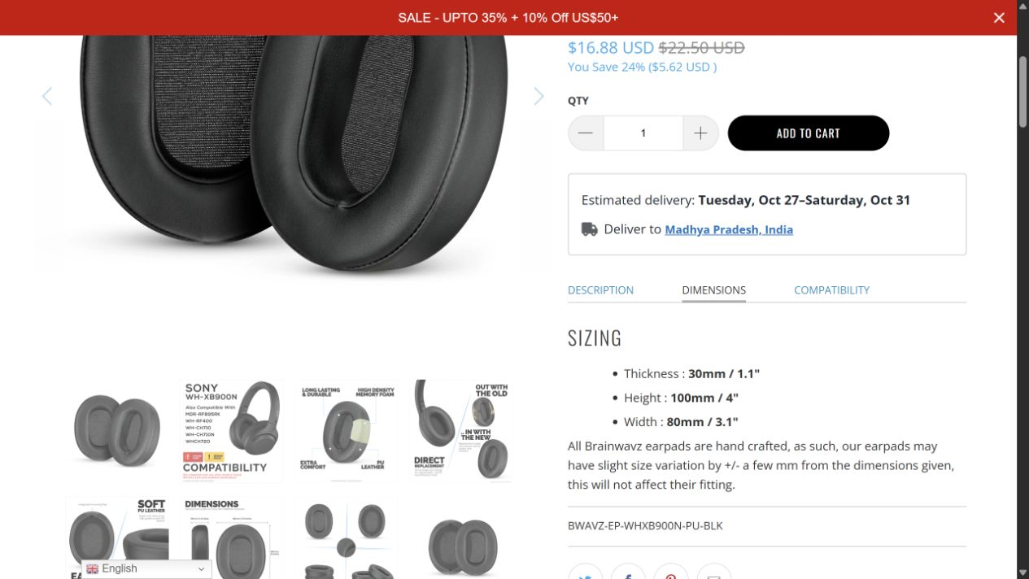
Brainwavz sizing panel for its compatible aftermarket pad. Not Sony OEM mounting metrology.
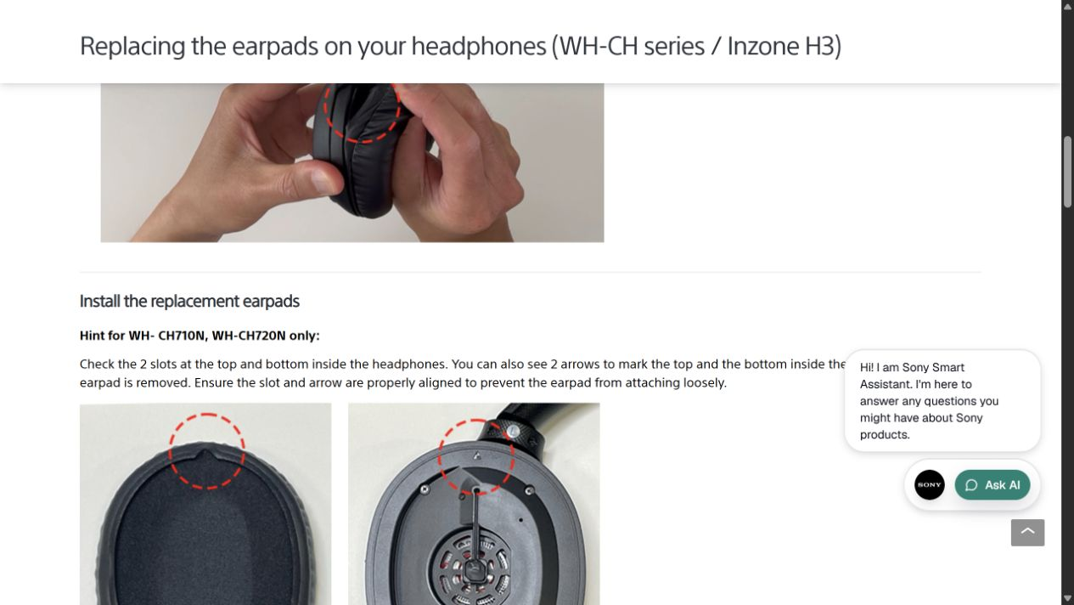
Sony instructions explicitly identify WH CH720N alignment features. No scale or groove dimensions are given.
Brainwavz compatible pad dimensions and model list
Sony replacement instructions for the WH CH series
Saved evidence: engineering-v20-results contains internet_sources.json, design_parameters.json, CAD_verification.json, contact_summary.json, contact_controls.json, verification.json, saved_audit_rerun.json, scenario CSVs and the source screenshots. Source scripts are v20_preprototype_screen.py, verify_v20_screen.py and build_v20_flex_reference.py. The first ellipse build error is preserved in CAD_build_trials.json.

